

**CC4057NI Introduction to Information Systems**

**60% Group Coursework**

**2022-23 Autumn**

|  |  |  |  |
| --- | --- | --- | --- |
| **Group Name:** | | | |
| **SN** | **Student Name** | **College ID** | **University ID** |
| **1** | **Aayush Shrestha** | **NP01CP4A230223** | **23050351** |
| **2** | **Tulsi Thakur** | **NP01CP4A230447** | **23050397** |
| **3** | **Utsav Mardan Basnyat** | **NP01CP4A230455** | **23049039** |

**Assignment Due Date: Wednesday, January 31, 2024**

**Assignment Submission Date: Wednesday, January 31, 2024**

**Word Count: 9468**

**Project File Links:**

|  |  |
| --- | --- |
| **Google Drive Link:** | **https://drive.google.com/drive/folders/1UVvhVLQtmLbFyYTH-B7u-3M8A8vMgU0w?usp=sharing** |

*I confirm that I understand my coursework needs to be submitted online via MySecondTeacher under the relevant module page before the deadline in order for my assignment to be accepted and marked. I am fully aware that late submissions will be treated as non-submission and a marks of zero will be awarded.*

**Table of content**

1. Introduction 1

1.1 Goals and objective 1

1.2 Website Development 2

2. Text Editor and Wireframe 3

2.1 Balsamiq Wireframes 3

2.2 Visual Studio Code 3

3. Pages 4

3.1 Home 4

3.1.1 Home Wireframe 5

3.1.2 Home Actual Page 6

3.2 Blog 7

3.2.1 Blog wireframes 7

3.2.2 Blog Actual Page 8

3.3 Products 8

3.3.1 Products wireframe 9

3.3.2 Products Actual page 10

3.4 Research 11

3.4.1 Research wireframe 12

3.4.2 Research actual page 13

3.5 About Us 13

3.5.1 About us wireframes 14

3.5.2 About Us Actual page 15

4. Test 16

4.1 Test 1 - Testing Product Description (JS) 16

4.2 Test 2 - Testing Confirm Purchase Popup (JS) 17

4.3 Test 3 – Testing Feedback form validation (JS) 20

4.4 Test 4 - Testing navbar hover effect 22

4.5 Test 5 – Testing internal and external links 22

5. Conclusion 25

6. References 26

7. Appendix 27

7.1 HTML of home page (Index.html) 27

7.2 HTML page of blogs (Blog.html) 36

7.3 HTML page of product page (Products.html) 47

7.4 HTML page of Research page (Research.html) 66

7.5 HTML of About Us page (Aboutus.html) 75

7.6 CSS (Style.css) 86

7.7 JavaScript (ProductsScript.js) 89

**Table of figures**

Figure 1: Wireframe of Home page 5

Figure 2: Actual homepage top 6

Figure 3: Actual home page bottom 6

Figure 4: Wireframe of Blog page 7

Figure 5: Actual Blog page 8

Figure 6: Wireframe of Product page 9

Figure 7: Actual Product page 10

Figure 8: Product description in product page 11

Figure 9: Wireframe of Research page 12

Figure 10: Actual Reference page 13

Figure 11: Wireframe of the About us page 14

Figure 12: About us actual page top 15

Figure 13: About us actual page bottom 15

Figure 14: Test 1 - Clicking the view detail of product in Product page 16

Figure 15: Test 1- Product Info displayed after clicking view details 17

Figure 16: Test 2 - Clicking the view detail of product in Product page 18

Figure 17: Test 2- Product Info displayed after clicking view details 18

Figure 18: Test 2 - Popup displayed after clicking on buy button 19

Figure 19: Test 2 - Popup displayed after clicking ok in the confirmation popup 19

Figure 20: Test 3 - Navigating to About Us page 20

Figure 21: Test 3 - Filling the form 21

Figure 22: Test 3 - Popup saying thank you to the user 21

Figure 23: Test 4 - Hovering over text on navbar 22

Figure 24: Test 5 - Navigating to products page 23

Figure 25: Test 5 - Redirected to products page 23

Figure 26: Test 5 - Navigating to footer section 24

Figure 27: Test 5 - Redirected to Facebook page 24

**Table of tables**

Table 1: Test 1 - Testing Product Description (JS) 16

Table 2: Test 2 - Testing Confirm Purchase Popup (JS) 17

Table 3: Test 3 – Testing Feedback form validation (JS) 20

Table 4: Test 4 - Testing navbar hover effect 22

Table 5: Test 5 – Testing internal and external links 22

# 1. Introduction

Websites have become an essential part of our daily lives, providing accessibility and convenience/ Websites are digital platform that provide different services like online transaction, communication and information exchange for various purpose including business, education and entertainment. Personal use of website include blogging and sharing details about interests and hobbies. A website acts as an online storefront for business, providing customers with ability to browse and purchase items or services (Bistricer, 2024).

In this project, we are required to make an e-commerce website of a printer store. The website is required to have 5 or more pages including home page, blog page, product page, contact us and research page. This website is to be created using HTML, CSS and JavaScript. Visual Studio code was used as a text editor as it was easier to code and it supported all three languages.

## Goals and objective

The main goal of this project is to teach us how to create a functioning e-commerce website, which is user friendly, looks good and has some functionality.

There are many objectives of this project, it teaches us how to create a functioning website, how to use the HTML, CSS and JS in a skilful way in order to achieve a beautiful and working website. It also enables students to understand how html incorporates CSS and JS in a website. The website must have five pages or more in total, the five page includes a home page, a product page which consists of all the products available, a blog page which consists of information about the technology and their advantages and disadvantages, research page which consists of the references that we took from other websites and finally the contact us page which consists of a feedback form and details of the team members. It also allows us to learn to work in team and enhance our group performance

## 1.2 Website Development

For developing this website, HTML, CSS and JavaScript were used:

1. **HTML**

HTML stands for Hypertext Markup Language. It is a standard markup language for creating web pages. It lets you to create and arrange sections, paragraphs, and links with HTML components like tags and attributes (S., 2023). It was used to make the skeleton of the website. Different tags like div, nav, p, img, table, etc were used to give structure to the webpage.

1. **CSS**

CSS stands for Cascading Style Sheet. CSS is a language used to style components expressed in markup languages like HTML. It distinguishes the site's visual appearance from its content. HTML and CSS are inextricably linked since HTML is the core backbone of a site and CSS encompasses all of the aesthetics of a website (G., 2023). When developing the webpages, CSS was used to make the website look nice, appear more beautiful and cleaner, making the website look visually good.

1. **JavaScript**

JavaScript is a programming language that makes the webpage function. It was used in this project to make form validation and purchase validations in the website.

# 2. Text Editor and Wireframe

## 2.1 Balsamiq Wireframes

It is a tool that is user-friendly and is used to make the wireframes of a website. It allows users to drag and drop different elements which makes it easier to develop a prototype of a website. Balsamiq Wireframes was used in this project to create a prototype of the website and create the base structure of the website using the available elements in the software. It helped us design a good-looking prototype on which we decided to start working on developing the website.

## 2.2 Visual Studio Code

Visual Studio (VS) Code is an open-source code editor designed especially for correcting and repairing coding problems in cloud and online applications. Microsoft created VS Code, which is compatible with macOS, Linux, and Windows. Any written code can have its functionality improved with the help of VS Code's features. VS Code uses the same editing component as Azure DevOps, which is based on the Electron framework. This allows users to sync code between the server and the editor without downloading additional software by combining different FTP extensions (Uchendu, 2021).It was used in this project as the text editor as it is easier to code in this software and it also supports all three HTML, CSS and JS. It also has some extensions like live server which makes it easer to see what we are developing.

# 3. Pages

## 3.1 Home

This is the main page of the website which we see after we open the website. It consists of a nav bar, a div for image, a div for content and a div for footer. In the nav bar, there is a logo in the left side, followed by links to navigate between the pages in the middle and a search bar in the right most part of the navigation bar. The div created for background image has texts that tells us about the website in short with a big red button that redirects the users to the product section. After that below is the division for all the content present in the home page which further has paragraph that describes the website and some division inside for products on sale. After that there is a footer which has all the links for pages available in the website on the left and also links for different social media platforms on the right followed by a copyright below the links.

### 3.1.1 Home Wireframe

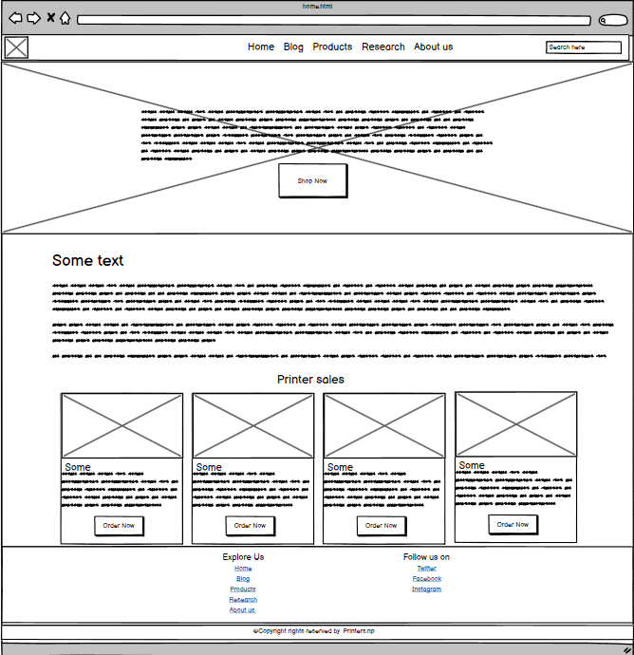

Figure 1: Wireframe of Home page

### 3.1.2 Home Actual Page

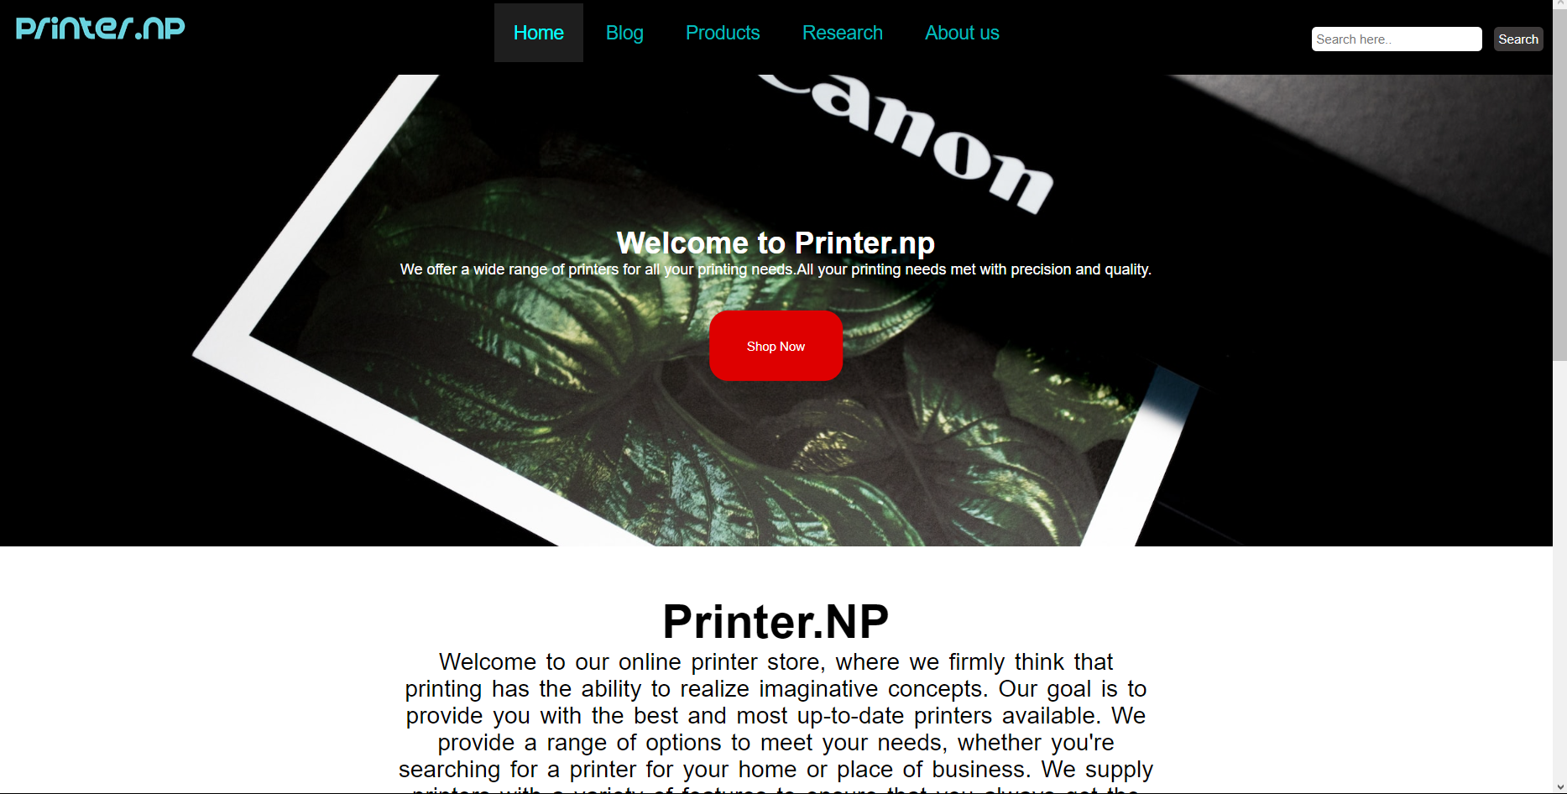

Figure 2: Actual homepage top

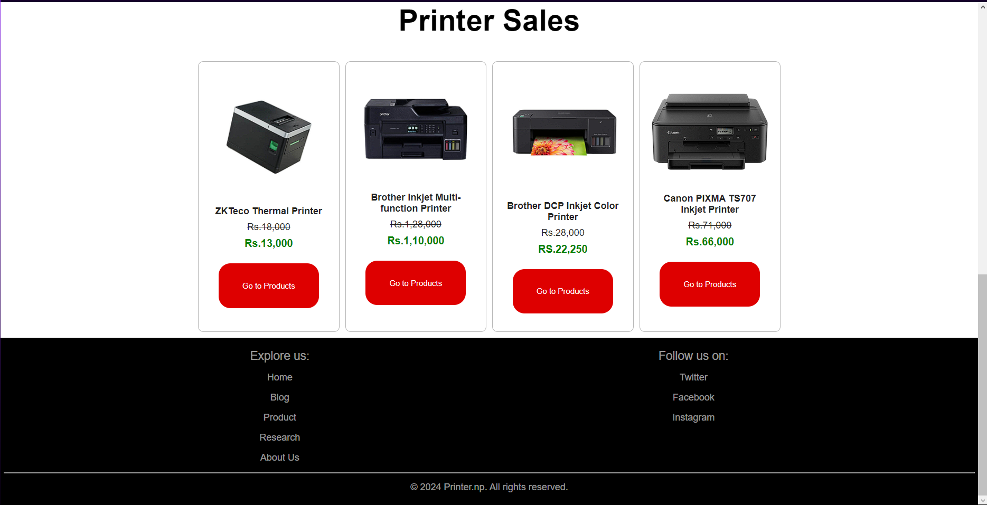

Figure 3: Actual home page bottom

## 3.2 Blog

The second page in a website consist a blog page. Adding blog page in our website helps us to talk and share information. The logo is kept in the header area. The body begins with the title Blog. There is a div container that contains all the cards that has the information in the blog section. In the container it is further divided into two parts left column and right column. In the left column there are different cards and each cards contains the heading of the information a photo and some descriptions. In the right column it has a unordered list which contains all the links to the cards of the blog. CSS was used in this page to beautify the cards and make the cards pop out from the rest of the body. There is a footer at the bottom of the page which has a link to all the pages on the right and on the left is the follow us which contains link to different social media.

### 3.2.1 Blog wireframes

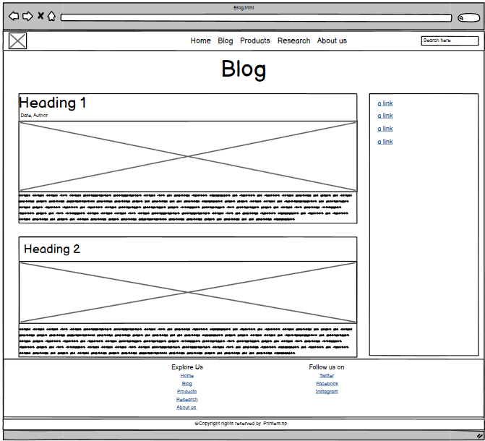

Figure 4: Wireframe of Blog page

### 3.2.2 Blog Actual Page

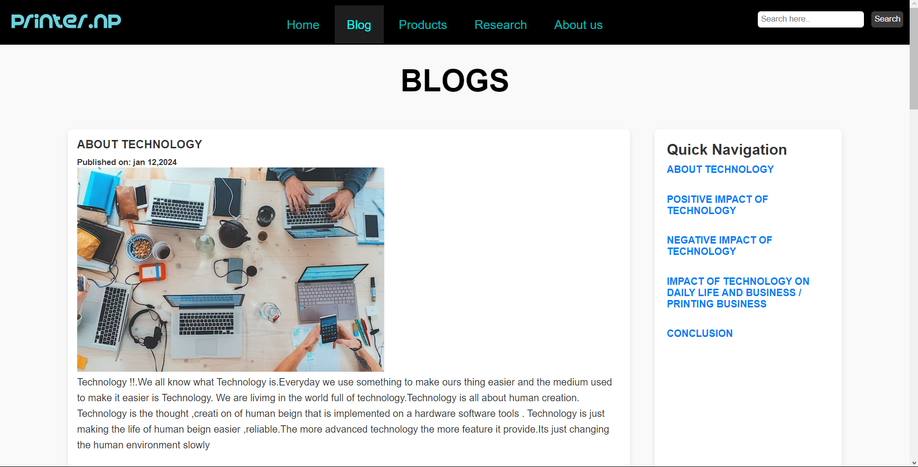

Figure 5: Actual Blog page

## 3.3 Products

The products page contains all the information about the products available in our website. The product page is divided into four parts, first one being navigation bar in the top of the website, product container which contains all the products, product details division which contains all products details and is hidden and finally the footer part which is in the bottom of the webpage. The products are arranged inside a table having three rows, each row of table containing four products. Each product has its own card. Each product card has an image of the product, Product Name and view details button to view details which hides all the products and displays the information about the product that we clicked. In the product details there is a photo on the left and on the right, there is name, key features and a buy now button which prompts out a conformation if they want to purchase on clicking the button. The footer contains all the links to the pages in the left and on the right, there is links of the social media sites.

### 3.3.1 Products wireframe

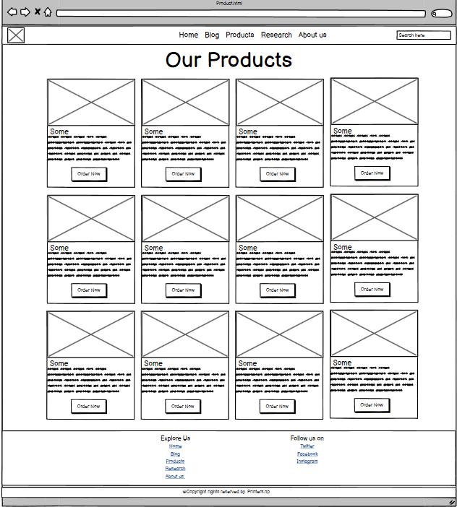

Figure 6: Wireframe of Product page

### 3.3.2 Products Actual page

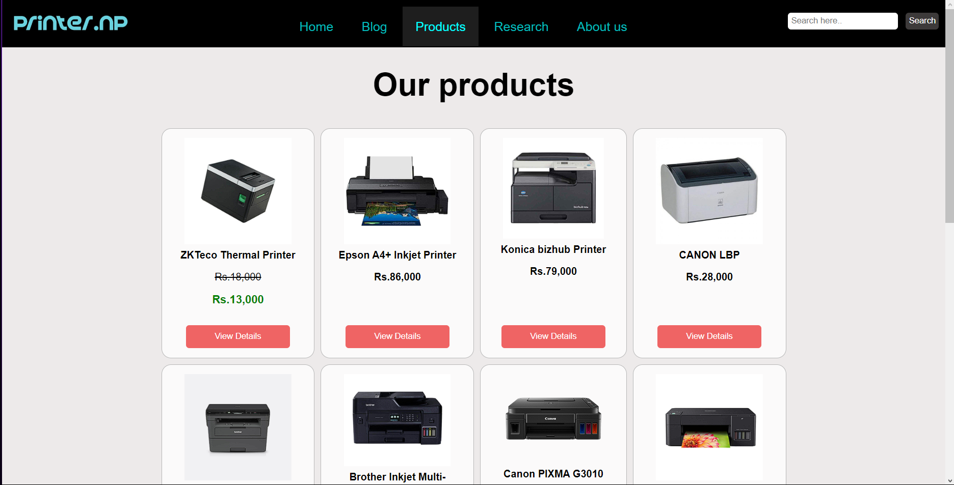

Figure 7: Actual Product page

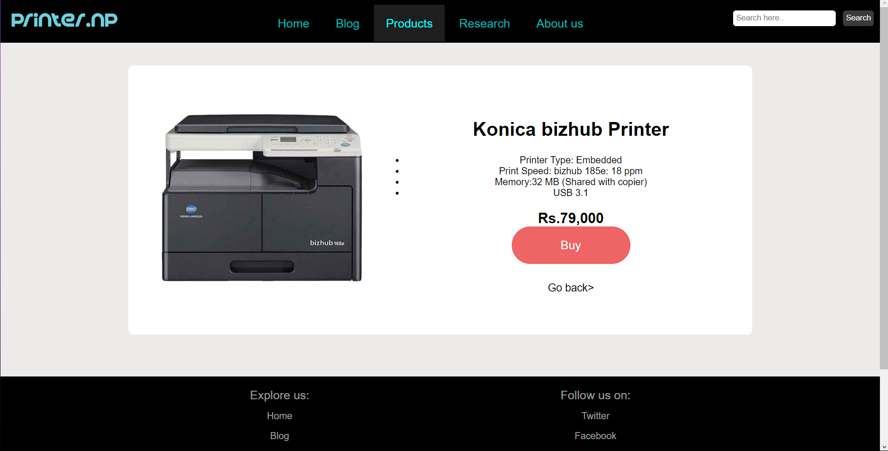

Figure 8: Product description in product page

## 3.4 Research

The "Research page" is the fourth page on this website. All of the references we used to construct the website are included on the research page. The navigation bar and our logo are included in the header area. We displayed the screenshots of the reference page and our original page side by side using the div tag. At the bottom of every reference was a brief biography of them. A list of all the webpages and social media platforms is located in the Footer section at the bottom. From there, we may explore and follow every page on social media.

### 3.4.1 Research wireframe

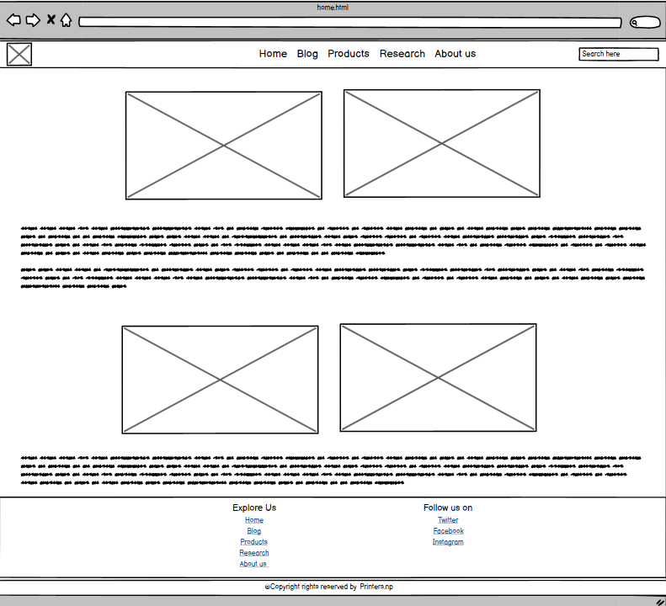

Figure 9: Wireframe of Research page

### 3.4.2 Research actual page

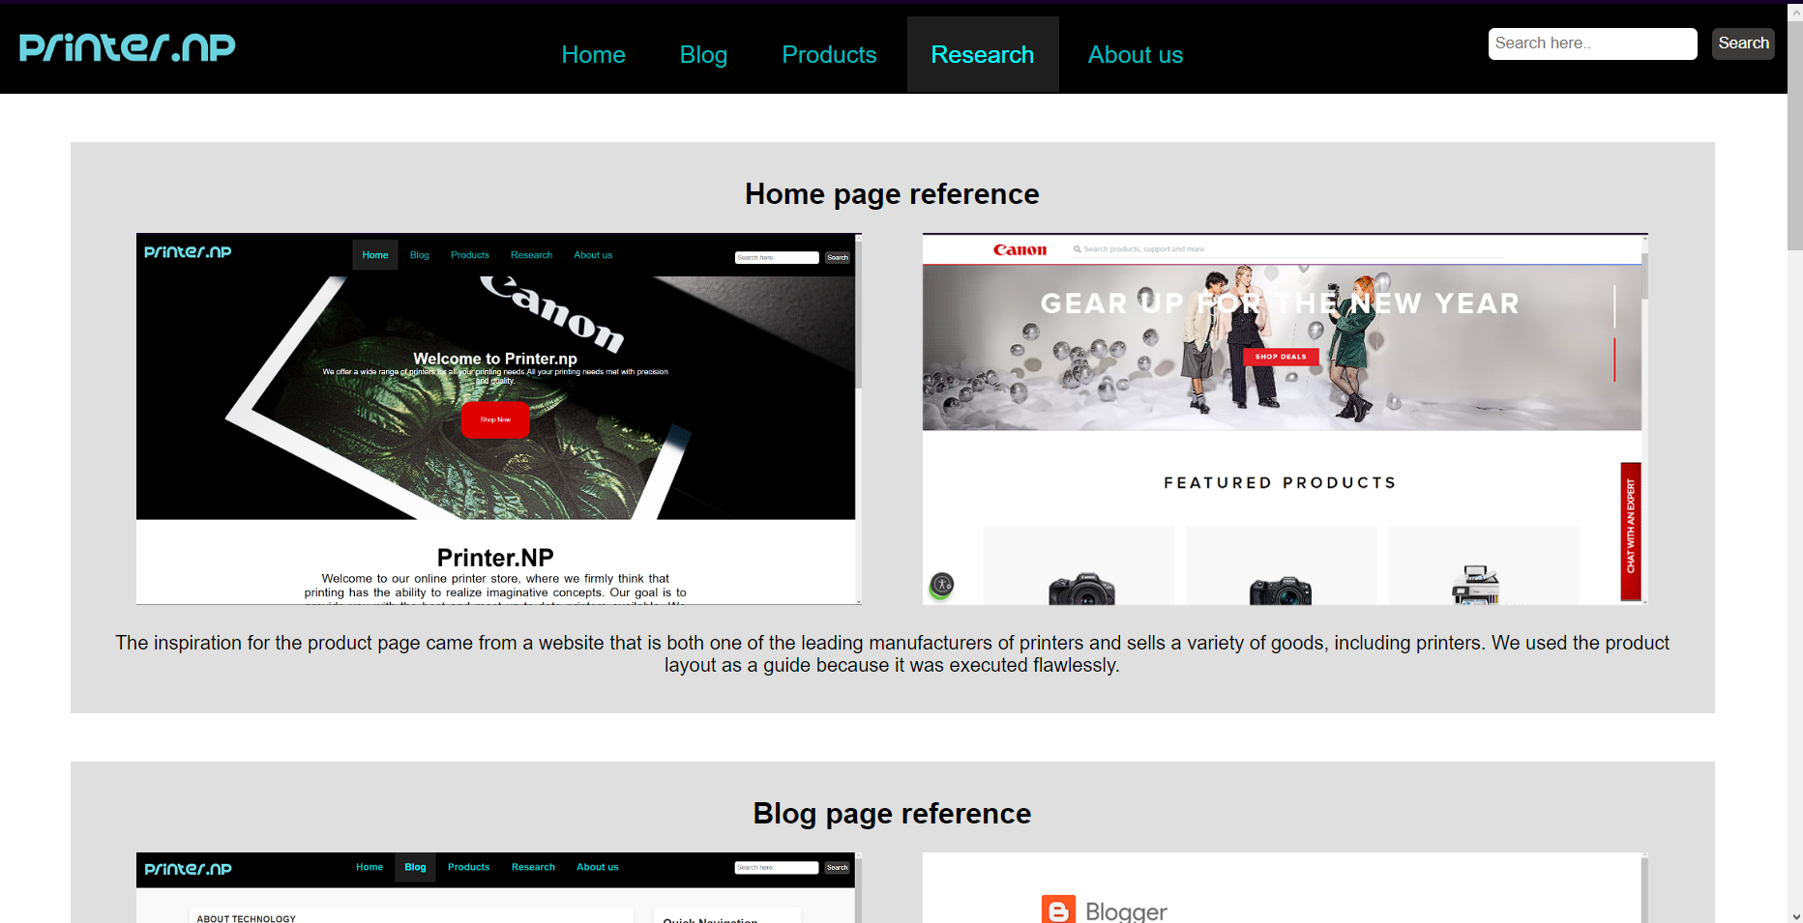

Figure 10: Actual Reference page

## 3.5 About Us

The last page of the website, the "about us" page, provides a brief bio of our team members and their expertise in this area. The navigation bar and our logo are included in the header area. The body begins with a heading, About us page. Using a div tag, we first added a background image. Next, we again used a div tag to construct a feedback form within the background image. After that there is our second heading, Our Team. Below that we used 3 divs for the portfolio of each member with their photo and short description in it. A list of all the webpages and social media platforms is located in the Footer section at the bottom. From there, we may explore and follow every page on social media.

### 3.5.1 About us wireframes

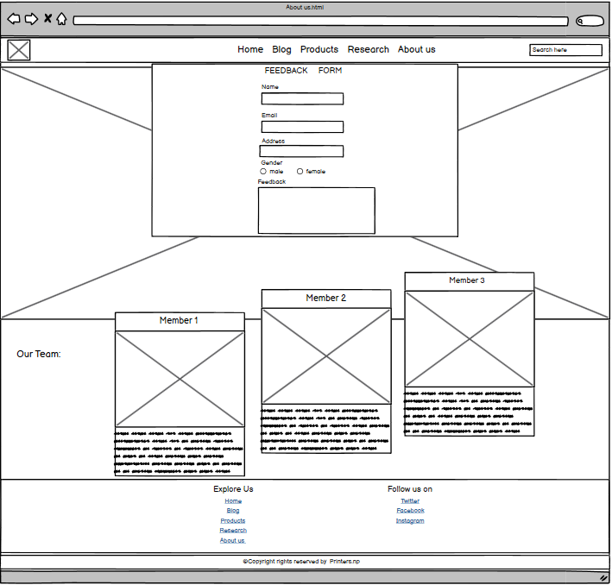

Figure 11: Wireframe of the About us page

### 3.5.2 About Us Actual page

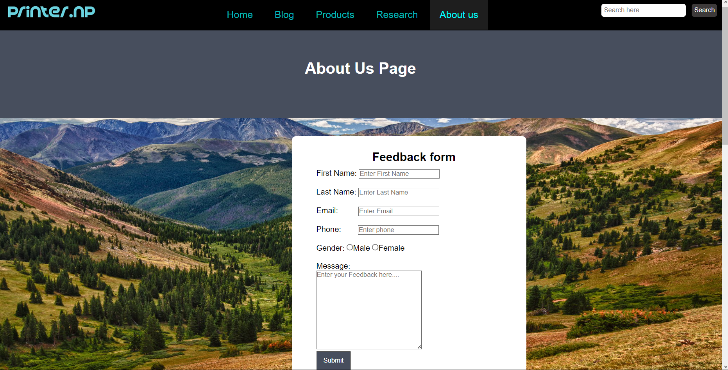

Figure 12: About us actual page top

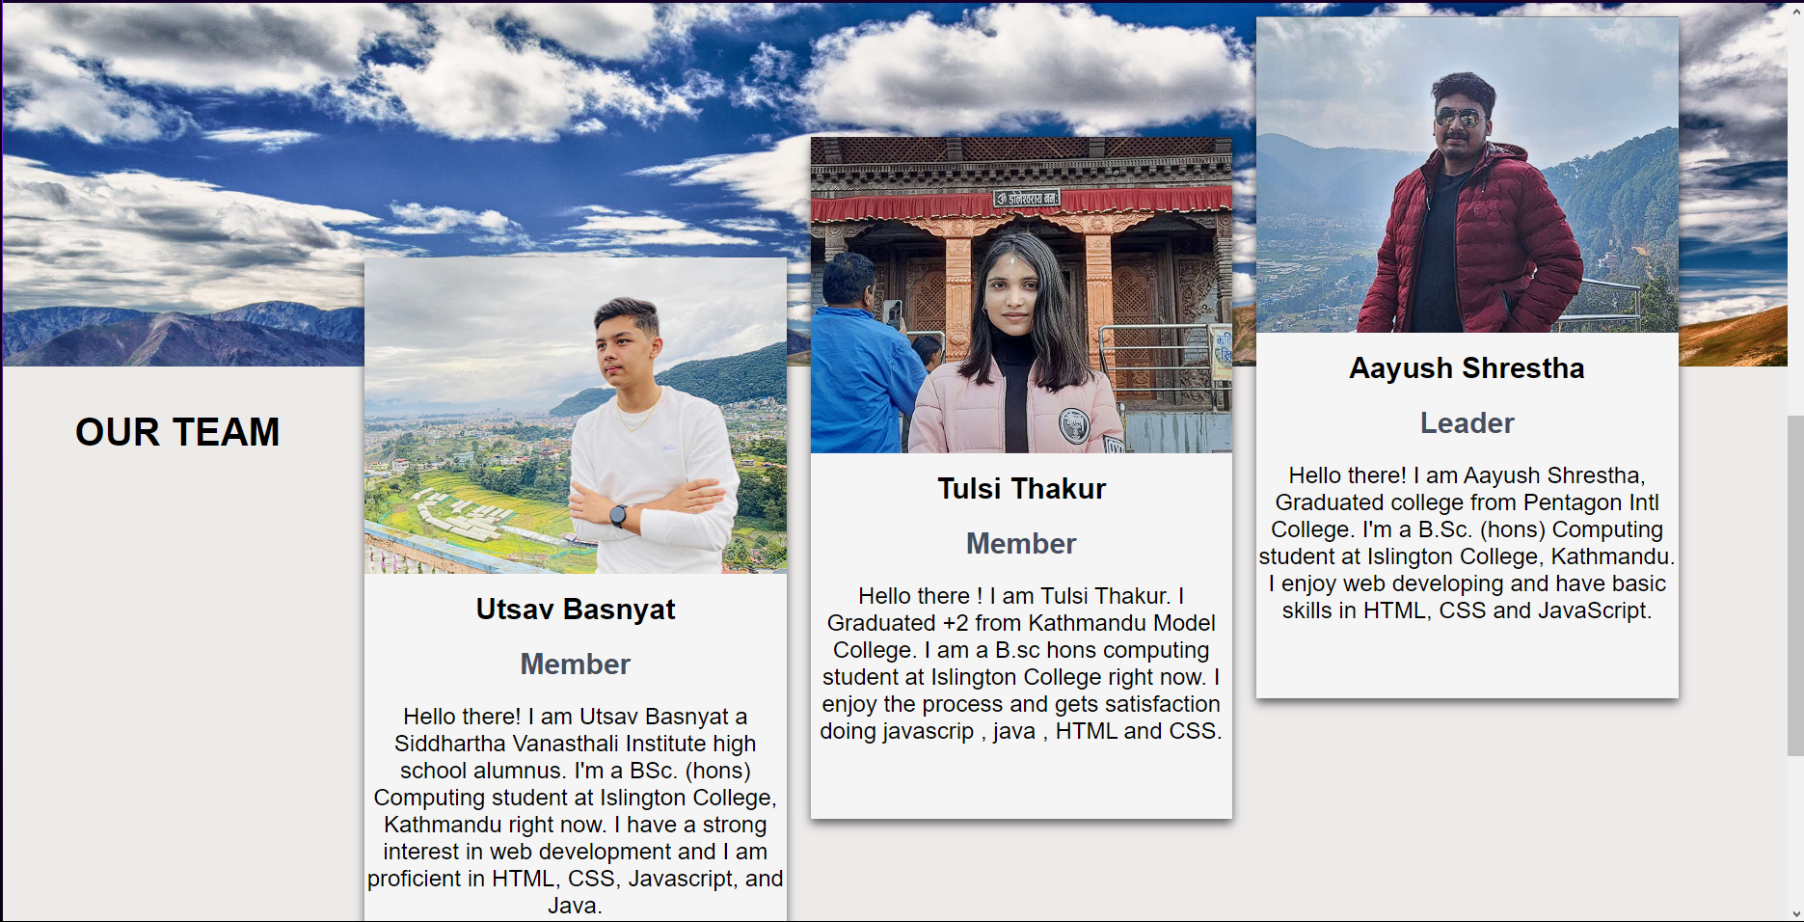

Figure 13: About us actual page bottom

# 4. Test

## 4.1 Test 1 - Testing Product Description (JS)

|  |  |
| --- | --- |
| Test No: | 1 |
| Objective: | To test the Product Description |
| Action: | * Navigate to product page * Clicking view details of any products |
| Expected Result | Only the product details of the clicked product would be shown |
| Actual Result | Only the detail of the clicked product was shown |
| Conclusion | The test is successful |

Table 1: Test 1 - Testing Product Description (JS)

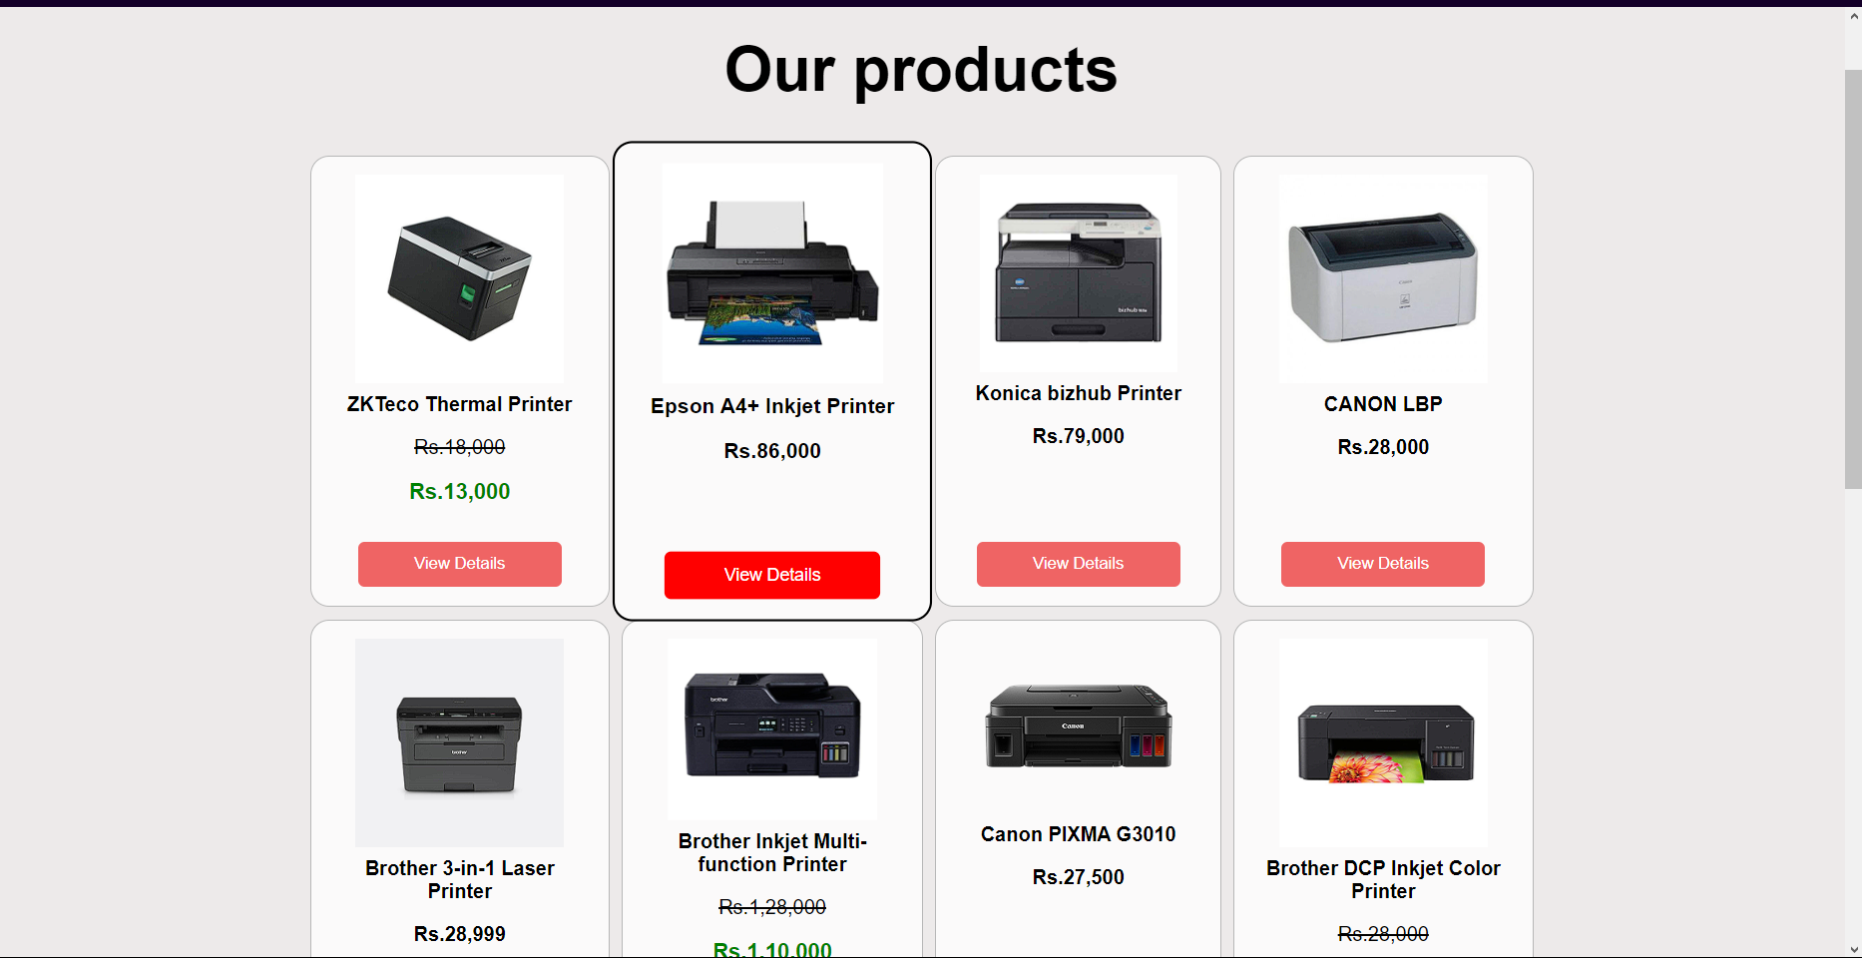

Figure 14: Test 1 - Clicking the view detail of product in Product page

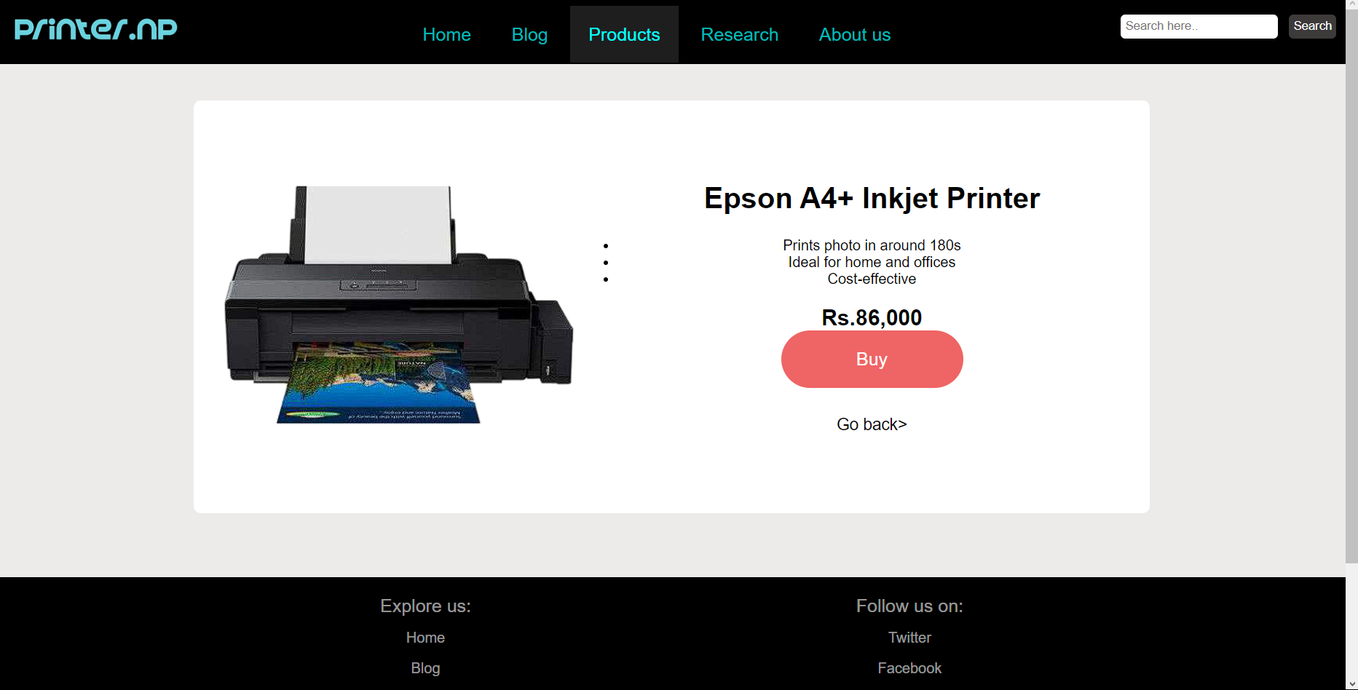

Figure 15: Test 1- Product Info displayed after clicking view details

## 4.2 Test 2 - Testing Confirm Purchase Popup (JS)

|  |  |
| --- | --- |
| Test No | 2 |
| Objective: | To test Confirm Purchase popup |
| Action: | * Navigate to product page * Clicked view details of any products * Clicked Buy Now button * Clicked Ok in the Confirmation popup |
| Expected Result: | New popup would appear that would confirm the purchase |
| Actual result | New popup appeared that confirmed the purchase |
| Conclusion | The test is successful |

Table 2: Test 2 - Testing Confirm Purchase Popup (JS)

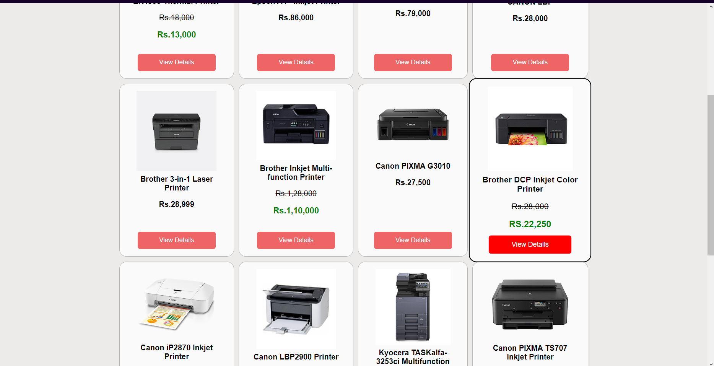

Figure 16: Test 2 - Clicking the view detail of product in Product page

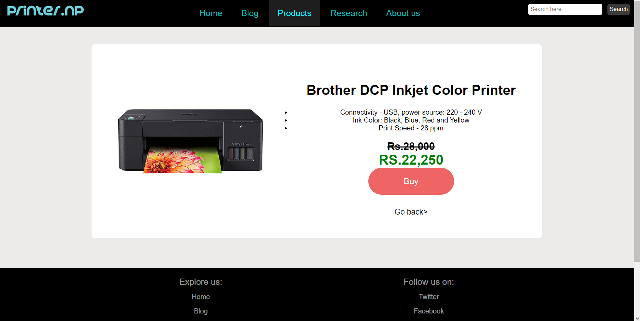

Figure 17: Test 2- Product Info displayed after clicking view details

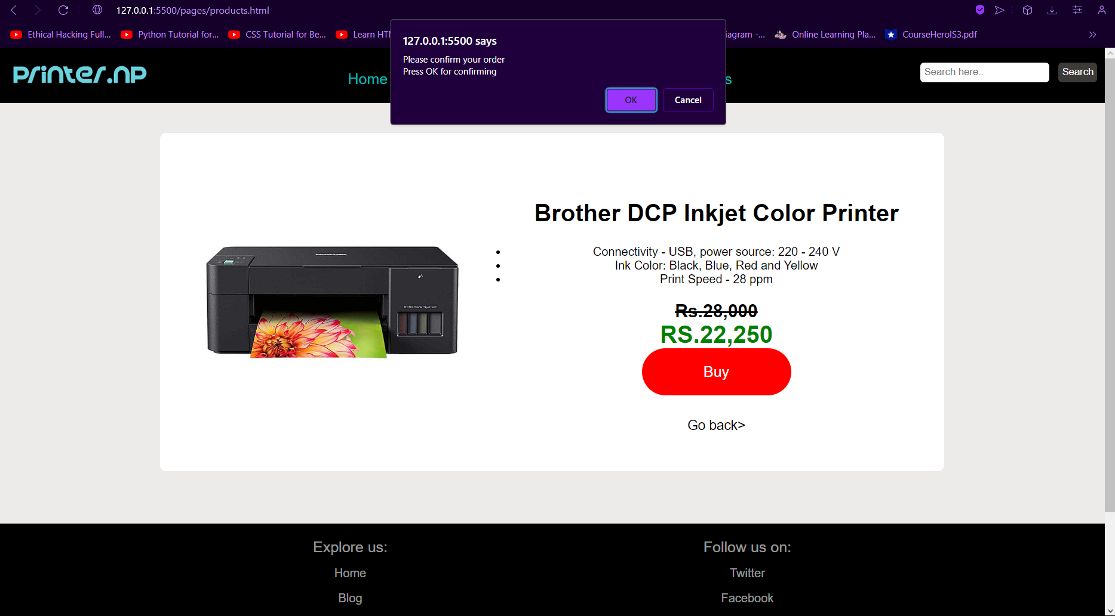

Figure 18: Test 2 - Popup displayed after clicking on buy button

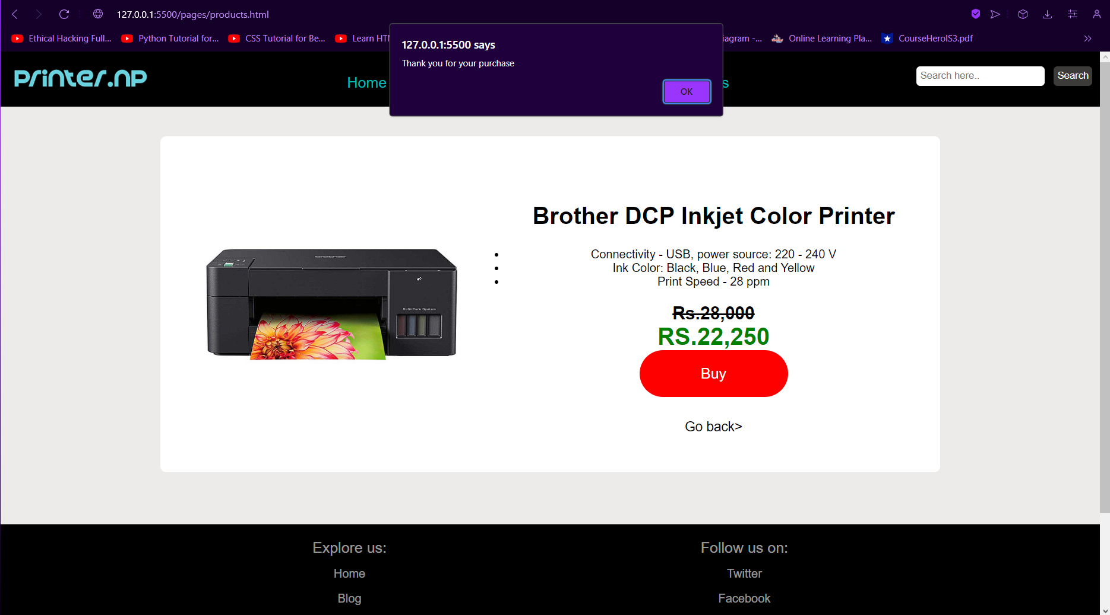

Figure 19: Test 2 - Popup displayed after clicking ok in the confirmation popup

## 4.3 Test 3 – Testing Feedback form validation (JS)

|  |  |
| --- | --- |
| Test no | 3 |
| Objective: | To test feedback form validation |
| Actions: | * Navigate to About us from navigation bar * Filling all the details and message in the fields * Clicking on submit |
| Expected Result | Popup message would appear thanking the user |
| Actual Result | Popup message appeared thanking the user |
| Conclusion | Test is successful |

Table 3: Test 3 – Testing Feedback form validation (JS)

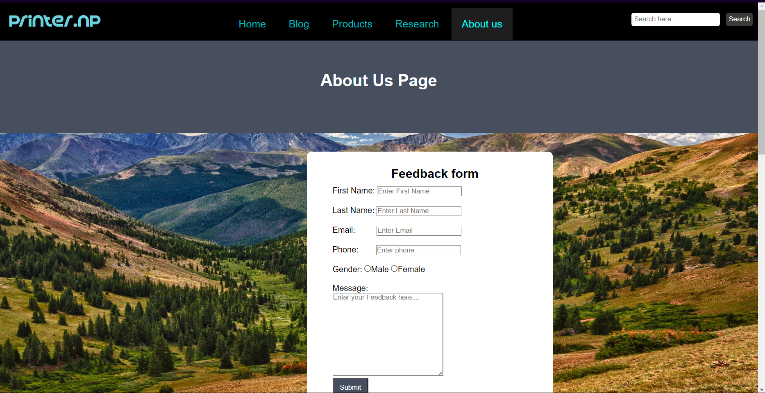

Figure 20: Test 3 - Navigating to About Us page

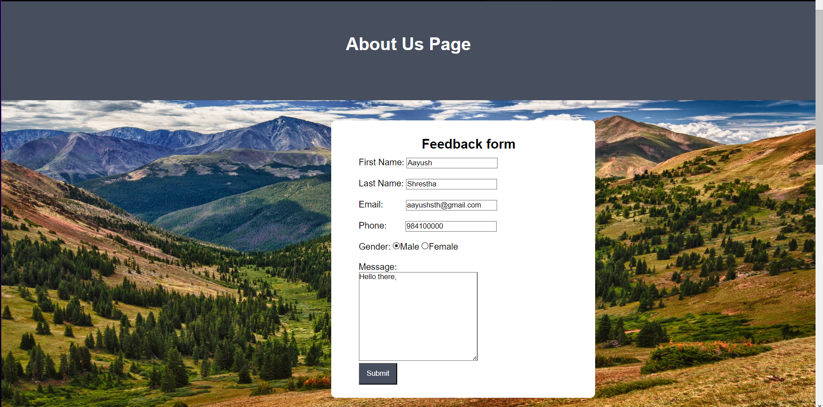

Figure 21: Test 3 - Filling the form

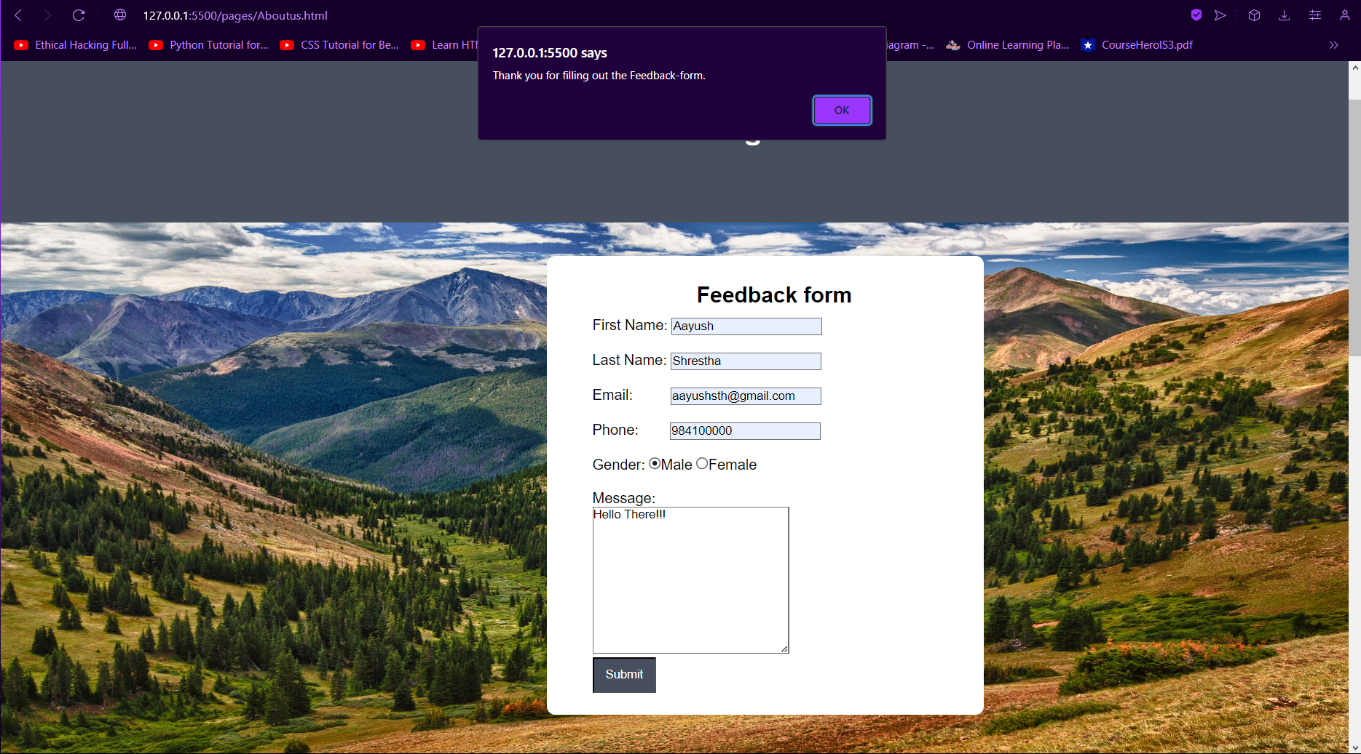

Figure 22: Test 3 - Popup saying thank you to the user

## 4.4 Test 4 - Testing navbar hover effect

|  |  |
| --- | --- |
| Test No | 4 |
| Objective: | To test navbar hover effect |
| Action: | The cursor is placed above the text on the navbar |
| Expected Result | The colour of the text and the textbox would change |
| Actual Result | The colour of the text and the textbox changed |
| Conclusion | The test is successful |

Table 4: Test 4 - Testing navbar hover effect

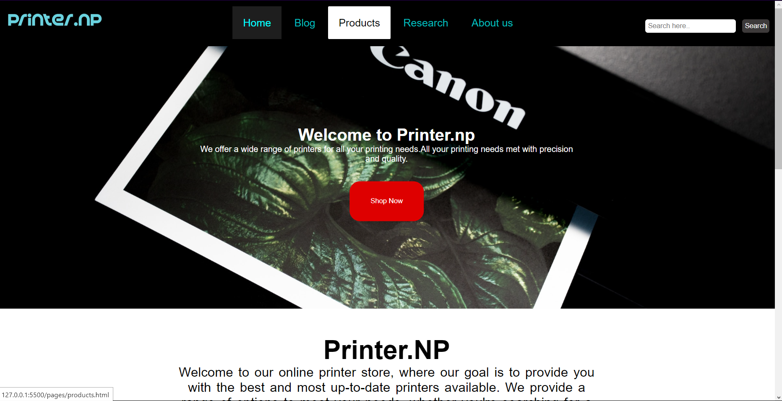

Figure 23: Test 4 - Hovering over text on navbar

## 4.5 Test 5 – Testing internal and external links

|  |  |
| --- | --- |
| Test No | 5 |
| Objective: | To test external and internal links |
| Actions: | 1. Navigate to home page and click on products page in the nav bar 2. Navigate to footer and click on Facebook |
| Expected Result: | 1. It would open products page of our website 2. It would open Facebook in new tab |
| Actual Result | 1. It opened product page of our website 2. It opened Facebook in the new tab |
| Result: | The test is successful |

Table 5: Test 5 – Testing internal and external links

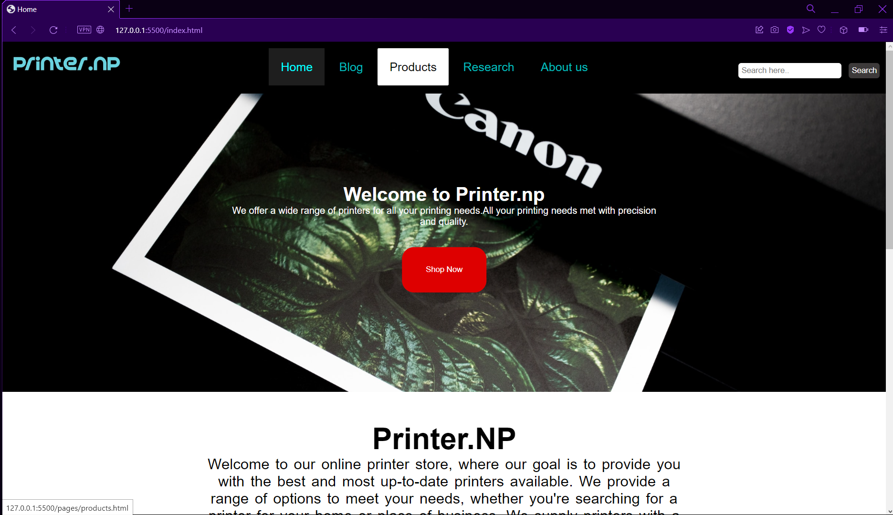

Figure 24: Test 5 - Navigating to products page

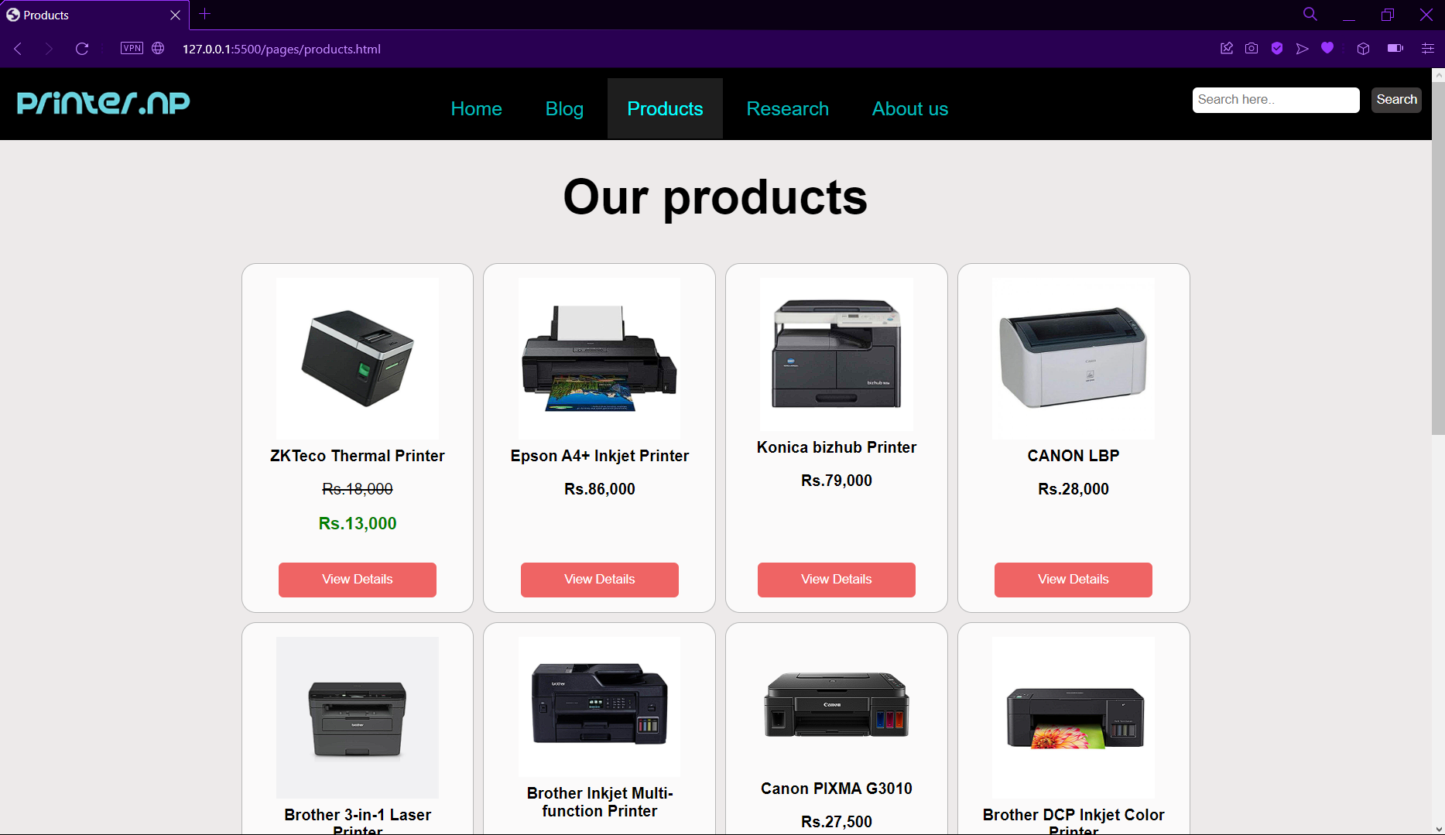

Figure 25: Test 5 - Redirected to products page

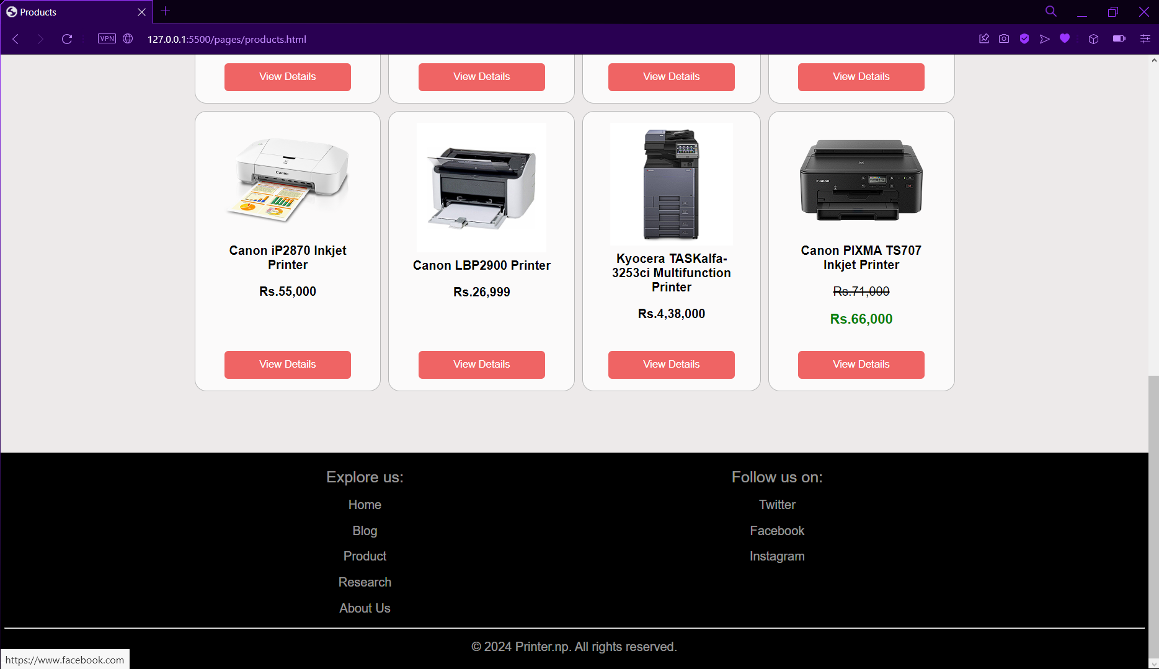

Figure 26: Test 5 - Navigating to footer section

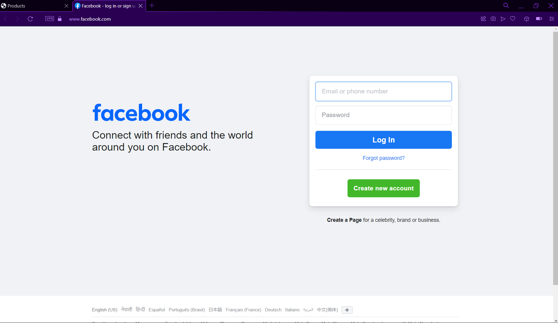

Figure 27: Test 5 - Redirected to Facebook page

# 5. Conclusion

This coursework is a project done in a group and the website is built using HTML, CSS and JavaScript. It taught us many things about how the websites functions and works. As a beginner, we all found it really challenging developing our own ecommerce website but we overcame the challenges and we learnt new things everyday through different online platforms like w3school, YouTube and other online learning platforms and we were able to build a working website. By learning and re practicing each content of the course it was also of great help in this project.

The aim of this coursework is to make a basic website and make us familiar to the tags and elements of the website. In this project, we got to work as a group and got to experience what working in group is like. We were able to complete this project by helping each other and completing this project by dividing works to the individual people of the group so everyone could contribute to this project and complete this project on time. This coursework was not easy but with the help of teachers and friends we were able to complete the coursework. We used different websites as a reference and we were able to design and make our websites using those references. It helped us understand how developing a website looks like from the start to the end. It was a really good experience learning in group, learning new things and fixing each other’s mistakes.

We also got ideas of how the website has the colour coding systems. We learned how to choose the colours for the website and how to make it look appealing to the consumers of the website. This assignment also helped us improve our research skill and also writing skills. This coursework also taught us a lot of things, all the research done to complete this project would also surely be important in the upcoming days.

# 6. References

Bistricer, R., 2024. *What is a website? Definition + examples.* [Online]   
Available at: https://www.wix.com/blog/what-is-a-website  
[Accessed 29 January 2024].

G., D., 2023. *What is CSS and how does it work?.* [Online]   
Available at: https://www.hostinger.com/tutorials/what-is-css  
[Accessed 29 January 2024].

S., A., 2023. *What is HTML? The Basics of Hypertext Markup Language Explained.* [Online]   
Available at: https://www.hostinger.com/tutorials/what-is-html  
[Accessed 29 January 2024].

Uchendu, C. C., 2021. *What is visual studio code?.* [Online]   
Available at: https://www.webopedia.com/definitions/visual-studio-code/  
[Accessed 29 January 2024].

# 7. Appendix

## 7.1 HTML of home page (Index.html)

<!DOCTYPE html>

<html lang="en">

<head>

<!-- meta tags -->

<meta charset="UTF-8" />

<meta name="viewport" content="width=device-width, initial-scale=1.0" />

<meta name="author" content="Aayush Shrestha" />

<meta

name="keywords"

content="Printers for Sale, Buy Printers Online, High-Quality Printers, Affordable Printers, Best Home Printers, Office Printers, Inkjet Printers, Laser Printers, Wireless Printers, Color Printers, Multifunction Printers, Photo Printers, 3D Printers, Printer Deals, Printer Discounts"

/>

<meta

name="description"

content="Explore our store, where we provide the most high tech quality printer for your everyday printing needs"

/>

<!-- title of the page -->

<title>Home</title>

<!-- linking the stylesheet -->

<link rel="stylesheet" href="./css/Style.css" />

<!-- internal css start -->

<style>

/* To style the hero image */

.backgroundImage {

background-image: url("../images/background-home.jpg");

height: 500px;

background-position: center;

background-repeat: no-repeat;

background-size: cover;

}

/* To style the text of hero image */

.photoText {

text-align: center;

position: absolute;

top: 50%;

left: 50%;

transform: translate(-50%, -50%);

color: white;

}

/* To style the button on the image */

.shop {

padding: 20px 30px;

background-color: rgb(222 0 0);

border-radius: 20px;

color: white;

font-size: 20px;

}

/* To make the product container*/

.productContainer {

margin: auto;

padding: 0 20px;

max-width: 1000px;

width: 100%;

text-align: center;

}

/* To style the table containing the product card */

.productTable {

width: 100%;

border-spacing: 10px;

}

/* To style the product card */

.productCard {

padding: 15px;

width: 25%;

border: 1px solid #b7b7b7;

background-color: rgba(255, 255, 255, 0.77);

color: rgb(35, 35, 35);

border-radius: 9px;

transition: 0.5s;

}

/* To make the img fit the product card */

.productCard img {

max-width: 100%;

}

/* To style all the buttons on homepage*/

button {

background-color: rgb(239, 100, 100);

color: white;

padding: 10px 45px;

border: none;

border-radius: 5px;

margin-top: 15px;

margin-bottom: 15px;

cursor: pointer;

}

/* To style the button hover effect*/

button:hover {

background-color: red;

}

/* To style the product card hover effect */

.productCard:hover {

transform: scale(1.06);

border: 2px solid black;

}

/* To give margin to paragraph inside product card */

.productCard p {

margin: 8px;

}

/* To style the textContainer*/

.textContainer {

width: 800px;

margin: auto;

word-spacing: 3px;

text-align: center;

margin-top: 50px;

}

/* to style the paragraph of the text Container */

.textContainer p {

font-size: 25px;

}

/* To style the content part of the page */

.content {

margin: auto;

width: 1400px;

}

</style>

</head>

<body>

<!-- Navigation bar starts -->

<nav>

<!-- Division created for logo -->

<div class="logo">

<a href="Index.html"><img src="./images/logo.png" alt="logo" /></a>

</div>

<!-- division created for menu -->

<div class="menuItems">

<a href="Index.html" id="active">Home</a>

<a href="./pages/Blog.html">Blog</a>

<a href="./pages/Products.html">Products</a>

<a href="./pages/Research.html">Research</a>

<a href="./pages/Aboutus.html">About Us</a>

</div>

<!-- Division created for searchbar -->

<div class="searchBar">

<input

type="text"

name="Search"

id="searchBar"

placeholder="Search here.."

/>

<button>Search</button>

</div>

</nav>

<!-- Div created for hero image -->

<div class="backgroundImage">

<!-- Div created for hero text and button-->

<div class="photoText">

<h1>Welcome to Printer.np</h1>

<p>

We offer a wide range of printers for all your printing needs.All your

printing needs met with precision and quality.

</p>

<br />

<a href="./pages/products.html">

<button class="shop">Shop Now</button>

</a>

</div>

</div>

<!-- Division created for all the contents -->

<div class="content">

<!-- Division created for text -->

<div class="textContainer">

<h1 style="font-size: 50px">Printer.NP</h1>

<p>

Welcome to our online printer store, where our goal is to provide you

with the best and most up-to-date printers available. We provide a

range of options to meet your needs, whether you're searching for a

printer for your home or place of business. We supply printers with a

variety of features to ensure that you always get the perfect print

because every print job is unique. From compact personal printers to

fast business printers, we have everything you need. Come explore the

printing of the future with us, and feel free to use your imagination

in the present.

</p>

</div>

<!-- Division created for products sale -->

<div class="productContainer">

<div class="heading">

<h1 style="color: black; margin: 30px 0px; font-size: 50px">

Printer Sales

</h1>

</div>

<table class="productTable">

<tr class="productRow">

<td class="productCard">

<img src="./images/products/product1.jpg" alt="product 1" />

<p><b>ZKTeco Thermal Printer</b></p>

<p><del>Rs.18,000</del></p>

<p style="color: green; font-size: 110%"><b>Rs.13,000</b></p>

<a href="./pages/products.html">

<button>Go to Products</button>

</a>

</td>

<td class="productCard">

<img src="./images/products/product6.jpg" alt="product 6" />

<p><b>Brother Inkjet Multi-function Printer</b></p>

<p><del>Rs.1,28,000</del></p>

<p style="color: green; font-size: 110%"><b>Rs.1,10,000</b></p>

<a href="./pages/products.html">

<button>Go to Products</button>

</a>

</td>

<td class="productCard">

<img src="./images/products/product8.jpg" alt="product 8" />

<p><b>Brother DCP Inkjet Color Printer</b></p>

<p><del>Rs.28,000</del></p>

<p style="color: green; font-size: 110%"><b>RS.22,250</b></p>

<a href="./pages/products.html">

<button>Go to Products</button>

</a>

</td>

<td class="productCard">

<img src="./images/products/product12.png" alt="product 12" />

<p><b>Canon PIXMA TS707 Inkjet Printer</b></p>

<p><del>Rs.71,000</del></p>

<p style="color: green; font-size: 110%"><b>Rs.66,000</b></p>

<a href="./pages/products.html">

<button>Go to Products</button>

</a>

</td>

</tr>

</table>

</div>

</div>

<!-- end of product details container and Start of footer -->

<footer>

<!-- Division created for left column of footer -->

<div class="leftColumn">

<p style="font-size: 20px">Explore us:</p>

<p><a href="./index.html">Home</a></p>

<p><a href="./pages/blog.html">Blog</a></p>

<p><a href="./pages/products.html">Products</a></p>

<p><a href="./pages/Research.html">Research</a></p>

<p><a href="./pages/Aboutus.html">About Us</a></p>

</div>

<!-- Division created for right column of footer -->

<div class="rightColumn">

<p style="font-size: 20px">Follow us on:</p>

<p>

<a href="https://www.twitter.com" target="_blank">Twitter</a>

</p>

<p>

<a href="https://www.facebook.com" target="_blank">Facebook</a>

</p>

<p>

<a href="https://www.instagram.com" target="_blank">Instagram</a>

</p>

</div>

<div class="copyright">

<hr />

<p>&copy; 2024 Printer.np. All rights reserved.</p>

</div>

</footer>

<!-- End of footer -->

</body>

</html>

## 7.2 HTML page of blogs (Blog.html)

<!DOCTYPE html>

<html lang="en">

<head>

<!-- meta tags -->

<meta charset="UTF-8" />

<meta name="viewport" content="width=device-width, initial-scale=1.0" />

<meta name="author" content="Tulsi Thakur" />

<meta

name="keywords"

content="Printers for Sale, Buy Printers Online, High-Quality Printers, Affordable Printers, Best Home Printers, Office Printers, Inkjet Printers, Laser Printers, Wireless Printers, Color Printers, Multifunction Printers, Photo Printers, 3D Printers, Printer Deals, Printer Discounts"

/>

<meta

name="description"

content="Explore our store, where we provide the most high tech quality printer for your everyday printing needs"

/>

<!-- linking stylesheet -->

<link rel="stylesheet" href="../css/Style.css" />

<!-- title of the page -->

<title>Blog</title>

<style>

/* styling the body */

body {

margin: 0;

font-family: "Arial", sans-serif;

background-color: #f9f9f9;

color: #333;

}

/* to style the container that contains the left and right column */

.container {

display: flex;

max-width: 1300px;

margin: 20px auto;

overflow: hidden;

background-color: #f9f9f9;

}

/* to style left and right column combined */

.left-column,

.right-column {

padding: 20px;

border-radius: 8px;

}

/* to style the left column */

.left-column {

flex: 75%;

background-color: #f9f9f9;

border-top-left-radius: 8px;

border-bottom-left-radius: 8px;

}

/* to style the right column */

.right-column {

flex: 25%;

background-color: #f9f9f9;

border-top-right-radius: 8px;

border-bottom-right-radius: 8px;

}

/* to style the list of the navigation card */

.navigation-card ul li {

margin-bottom: 30px;

list-style: none;

}

/* to style the cards of the blog page */

.card {

margin-bottom: 20px;

padding: 15px;

background-color: #fff;

border-radius: 8px;

box-shadow: 0 4px 8px rgba(0, 0, 0, 0.1);

}

/* to style the navigation card */

.navigation-card {

padding: 20px;

background-color: #fff;

border-radius: 8px;

box-shadow: 0 4px 8px rgba(0, 0, 0, 0.1);

height: 100%;

}

/* to syle the h1 and h3 tags */

h2,

h3 {

color: #333;

margin-bottom: 10px;

}

/* to style the paragraph tags */

p {

line-height: 1.6;

margin-bottom: 15px;

}

/* to style the links in the navigation card */

.navigation-card a {

text-decoration: none;

color: #007bff;

font-weight: bold;

transition: color 0.3s ease;

}

/* to style the links in the navigation card on hover */

.navigation-card a:hover {

color: #0056b3;

}

</style>

</head>

<body>

<!-- navigation bar starts -->

<nav>

<div class="logo">

<a href="../Index.html"><img src="../images/logo.png" alt="logo" /></a>

</div>

<div class="menuItems">

<a href="../Index.html">Home</a>

<a href="./Blog.html" id="active">Blog</a>

<a href="./Products.html">Products</a>

<a href="./Research.html">Research</a>

<a href="./Aboutus.html">About Us</a>

</div>

<div class="searchBar">

<input

type="text"

name="Search"

id="searchBar"

placeholder="Search here.."

/>

<button>Search</button>

</div>

</nav>

<!-- heading that displays the heading Blog -->

<h1

style="

color: black;

margin: 30px 0px;

font-size: 50px;

text-align: center;

"

id="head"

>

BLOGS

</h1>

<!-- div that is the container of all the contents -->

<div class="container">

<!-- div that contains the left column and all the cards -->

<div class="left-column">

<!-- div created for a card -->

<div class="card">

<h3 id="post1">ABOUT TECHNOLOGY</h3>

<h5>Published on: jan 12,2024</h5>

<div class="image">

<img

src="../images/blog/technology.jpg"

alt="tecnology"

width="500px"

/>

</div>

<p>

Technology. We all know what Technology is. Every day we use

something to make our thing easier and the medium used to make it

easier is Technology. We are living in the world full of technology.

Technology is all about human creation. Technology is the thought,

creation of human being that is implemented on a hardware software

tools. Technology is just making the life of human being easier,

reliable. The more advanced technology the more feature it provide.

Its just changing the human environment slowly.

</p>

</div>

<!-- div created for a card -->

<div class="card">

<h3 id="post2">POSITIVE IMPACT OF TECHNOLOGY</h3>

<div class="image">

<img

src="../images/blog/technology.2.jpg"

alt="tecnology"

width="500px"

/>

</div>

<p>

Every morning from opening our eye in morning to closing our eye in

the night, we need technology. Once we open the eyes in the morning

everything starts with technology like alarm clock makes us awake.

Technology has not made our life easier instead it has been an

essential things in our lives. It has become a solution for every

problem on our lives like when we like to study, we can study it

from our device rather than opening our textbook. Technology has

made human to remember a time when one has to waits for a month for

receiving letter to just clicking the button to communicate.

Technology has made easier to communicate with the relatives ,

parents and with our close ones via various means like WhatsApp,

Instagram, messenger and made the world into a global village.

Technology has made a great positive impact in long distance

relation by connecting the two people around the corner of the world

via video conferencing, communication and feeling them like a real

time togetherness. Technology has created such a platform that

school and college can run their classes by virtually. Students can

access any kind of study materials from the internet. Student do not

have to depend only on the teacher rather can learn anything from

the internet. Various research has proved technology has helped the

students in various ways. They make the students more competitive.

</p>

</div>

<!-- div created for a card -->

<div class="card">

<h3 id="post3">NEGATIVE IMPACT OF TECHNOLOGY</h3>

<div class="image">

<img

src="../images/blog/technology.3.jpg"

alt="technolgy"

width="500px"

/>

</div>

<p>

Everything has its two side likewise; technology too gives positive

impacts and negative impacts. Increasing advancement in technology

has many negative impacts in human life and also the environment.

Technology has connected people via virtually which has created a

great distance in a family. Overtime and excessive use of technology

leads to different health problem. Advancement of technology has

made the things serious like students depend on the technology and

here the creativity level of students decrease. Excessive use of

technology leads to addiction and also consume the productive time.

With the rise in use of technology in all age group are slowing

declining face to face interaction. Overuse of technology has issued

in the sleeping routine. Many teenage uses their device whole night,

which to leads many problems like lack of concentration in the

class. Using of technology regularly without any time management,

leads to poor body posture. It mainly hampers our eyesight because

mobile, laptops and other device emit such a light which directly

hampers the human brain. Growing children are more sensitive in all

aspects from negative to positive things, and the use of technology

in these children brings many bad effects in them like losing social

connection, loosing concentration, aggressive behaviour, addiction

of technology, poor level of creativity.

</p>

</div>

<!-- div created for a card -->

<div class="card">

<h3 id="post4">

IMPACT OF TECHNOLOGY ON DAILY LIFE AND BUSINESS / PRINTING BUSINESS

</h3>

<div class="image">

<img

class="technology"

src="../images/blog/technology.4.jpg"

alt="technolgy"

width="500px"

/>

</div>

<p>

With technology there is an increased scope for financial stability.

Technology helped business to increase the productivity by allowing

to access data which helps in decision making process. Cloud

computing which is a great part of technology gives to access the

data from any device or also from any location. With rapidly

advancement of technology, business nowadays offer a great amount of

products and service to a customer via their device. In printing

business, technology uses as laser and inkjet which helps to give

output quicky as compared to traditional method.

</p>

</div>

<!-- div created for a card -->

<div class="card">

<h3 id="post5">CONCLUSION</h3>

<p>

Business and human should always use the technology in a

advantageous way to stay competitive in the global market.

Technology has made a greater way to have a easier life for human in

all sector from transportation to health sector and many more.

</p>

</div>

</div>

<!-- end of left column and start of right column -->

<div class="right-column">

<div class="navigation-card">

<h2>Quick Navigation</h2>

<ul>

<li><a href="#post1">ABOUT TECHNOLOGY</a></li>

<li><a href="#post2">POSITIVE IMPACT OF TECHNOLOGY</a></li>

<li><a href="#post3">NEGATIVE IMPACT OF TECHNOLOGY</a></li>

<li>

<a href="#post4"

>IMPACT OF TECHNOLOGY ON DAILY LIFE AND BUSINESS / PRINTING

BUSINESS</a

>

</li>

<li><a href="#post5">CONCLUSION</a></li>

</ul>

</div>

</div>

</div>

<!-- end of container and start of footer -->

<footer>

<!-- division for left column -->

<div class="leftColumn">

<p style="font-size: 20px">Explore us:</p>

<p><a href="../Index.html">Home</a></p>

<p><a href="./Blog.html">Blog</a></p>

<p><a href="./Products.html">Products</a></p>

<p><a href="./Research.html">Research</a></p>

<p><a href="./Aboutus.html">About Us</a></p>

</div>

<!-- division for right column -->

<div class="rightColumn">

<p style="font-size: 20px">Follow us on:</p>

<p>

<a href="https://www.twitter.com" target="_blank">Twitter</a>

</p>

<p>

<a href="https://www.facebook.com" target="_blank">Facebook</a>

</p>

<p>

<a href="https://www.instagram.com" target="_blank">Instagram</a>

</p>

</div>

<div class="copyright">

<hr />

<p>&copy; 2024 Printer.np. All rights reserved.</p>

</div>

</footer>

<!-- end of footer -->

</body>

</html>

## 7.3 HTML page of product page (Products.html)

<!DOCTYPE html>

<html lang="en">

<head>

<!-- meta tags -->

<meta charset="UTF-8" />

<meta name="viewport" content="width=device-width, initial-scale=1.0" />

<meta name="author" content="Aayush Shrestha" />

<meta

name="keywords"

content="Printers for Sale, Buy Printers Online, High-Quality Printers, Affordable Printers, Best Home Printers, Office Printers, Inkjet Printers, Laser Printers, Wireless Printers, Color Printers, Multifunction Printers, Photo Printers, 3D Printers, Printer Deals, Printer Discounts"

/>

<meta

name="description"

content="Explore our store, where we provide the most high tech quality printer for your everyday printing needs"

/>

<!-- title of the page -->

<title>Products</title>

<!-- linking the stylesheet -->

<link rel="stylesheet" href="../css/Style.css" />

<!-- linking the script -->

<script src="../javaScript/ProductsScript.js"></script>

<style>

/* To make the items align in center of the body */

body {

align-items: center;

background-color: #edeaea;

}

/* To style the product container */

.productContainer {

margin: auto;

padding: 0 20px;

max-width: 1000px;

width: 100%;

text-align: center;

}

/* To style the table that contains the products */

.productTable {

width: 100%;

border-spacing: 10px;

}

/* To style the product cards */

.productCard {

display: flex;

flex-direction: column;

justify-content: space-between;

align-items: center;

padding: 15px;

border: 1px solid #b7b7b7;

background-color: rgba(255, 255, 255, 0.77);

border-radius: 15px;

transition: 0.5s;

height: 330px;

}

/* Tp style the image inside the product card */

.productCard img {

max-width: 80%;

}

/* To make button present in the product card cone in the middle */

.productCard button {

margin-top: auto;

}

/* To style all the buttons present in the product page */

button {

background-color: rgb(239, 100, 100);

color: white;

padding: 10px 45px;

border: none;

border-radius: 5px;

cursor: pointer;

}

/* To make the buttons change colour on hover */

button:hover {

background-color: red;

}

/* To Style the buy button */

.buy {

width: 200px;

padding: 20px;

border-radius: 33px;

font-size: 20px;

margin-bottom: 30px;

}

/* To make the product card larger on hover */

.productCard:hover {

transform: scale(1.06);

border: 2px solid black;

}

/* To make the paragraph inside the product card seperated */

.productCard p {

margin: 8px;

}

/* To make some gyap on top and bottom of product detail container*/

.productDetailContainer {

margin-bottom: 70px;

margin-top: 40px;

}

/* To style the product detail */

.productDetail {

display: none;

padding: 25px;

background-color: white;

max-width: 1000px;

margin: auto;

border-radius: 8px;

}

/* To style the images div inside the product detail */

.images {

flex: 35%;

}

/* To Style the image inside the product detail card*/

.images img {

max-width: 400px;

}

/* To style the details div inside the product detail */

.details {

flex: 65%;

margin-left: 40px;

text-align: center;

margin-top: 65px;

}

/* To style the ul inside the product detail */

.details ul {

margin-bottom: 20px;

}

/* To style the back button */

.back {

font-size: 18px;

text-decoration: none;

border-radius: 9px;

color: black;

}

</style>

</head>

<body>

<!-- navigation bar starts -->

<nav>

<!-- division created for logo -->

<div class="logo">

<a href="../Index.html"><img src="../images/logo.png" alt="logo" /></a>

</div>

<!-- division created for links to other pages -->

<div class="menuItems">

<a href="../Index.html">Home</a>

<a href="./Blog.html">Blog</a>

<a href="./Products.html" id="active">Products</a>

<a href="./Research.html">Research</a>

<a href="./Aboutus.html">About Us</a>

</div>

<!-- div created for search bar -->

<div class="searchBar">

<input

type="text"

name="Search"

id="searchBar"

placeholder="Search here.."

/>

<button>Search</button>

</div>

</nav>

<!-- end of navigation bar and start of product container -->

<div class="productContainer" id="container">

<div class="heading">

<h1 style="color: black; margin: 30px 0px; font-size: 50px" id="head">

Our products

</h1>

</div>

<!-- table that contains all the products -->

<table class="productTable">

<tr>

<td>

<!-- division created for product card -->

<div class="productCard" id="product1">

<img src="../images/products/product1.jpg" alt="product 1" />

<p><b>ZKTeco Thermal Printer</b></p>

<p><del>Rs.18,000</del></p>

<p style="color: green; font-size: 110%"><b>Rs.13,000</b></p>

<button class="view" onclick="displayInfo(1)">

View Details

</button>

</div>

</td>

<td>

<!-- division created for product card -->

<div class="productCard" id="product2">

<img src="../images/products/product2.jpg" alt="product 2" />

<p><b>Epson A4+ Inkjet Printer</b></p>

<p><b>Rs.86,000</b></p>

<button class="view" onclick="displayInfo(2)">

View Details

</button>

</div>

</td>

<td>

<!-- division created for product card -->

<div class="productCard" id="product3">

<img src="../images/products/product3.jpg" alt="product 3" />

<p><b>Konica bizhub Printer</b></p>

<p><b>Rs.79,000</b></p>

<button class="view" onclick="displayInfo(3)">

View Details

</button>

</div>

</td>

<td>

<!-- division created for product card -->

<div class="productCard" id="product4">

<img src="../images/products/product4.jpg" alt="product 4" />

<p><b>CANON LBP</b></p>

<p><b>Rs.28,000</b></p>

<button class="view" onclick="displayInfo(4)">

View Details

</button>

</div>

</td>

</tr>

<tr>

<td>

<!-- division created for product card -->

<div class="productCard" id="product5">

<img src="../images/products/product5.jpeg" alt="product 5" />

<p><b>Brother 3-in-1 Laser Printer</b></p>

<p><b>Rs.28,999</b></p>

<button class="view" onclick="displayInfo(5)">

View Details

</button>

</div>

</td>

<td>

<!-- division created for product card -->

<div class="productCard" id="product6">

<img src="../images/products/product6.jpg" alt="product 6" />

<p><b>Brother Inkjet Multi-function Printer</b></p>

<p><del>Rs.1,28,000</del></p>

<p style="color: green; font-size: 110%"><b>Rs.1,10,000</b></p>

<button class="view" onclick="displayInfo(6)">

View Details

</button>

</div>

</td>

<td>

<!-- division created for product card -->

<div class="productCard" id="product7">

<img src="../images/products/product7.png" alt="product 7" />

<p><b>Canon PIXMA G3010</b></p>

<p><b>Rs.27,500</b></p>

<button class="view" onclick="displayInfo(7)">

View Details

</button>

</div>

</td>

<td>

<!-- division created for product card -->

<div class="productCard" id="product8">

<img src="../images/products/product8.jpg" alt="product 8" />

<p><b>Brother DCP Inkjet Color Printer</b></p>

<p><del>Rs.28,000</del></p>

<p style="color: green; font-size: 110%"><b>RS.22,250</b></p>

<button class="view" onclick="displayInfo(8)">

View Details

</button>

</div>

</td>

</tr>

<tr>

<td>

<!-- division created for product card -->

<div class="productCard" id="product9">

<img src="../images/products/product9.png" alt="product 9" />

<p><b>Canon iP2870 Inkjet Printer</b></p>

<p><b>Rs.55,000</b></p>

<button class="view" onclick="displayInfo(9)">

View Details

</button>

</div>

</td>

<td>

<!-- division created for product card -->

<div class="productCard" id="product10">

<img src="../images/products/product10.jpg" alt="product 10" />

<p><b>Canon LBP2900 Printer</b></p>

<p><b>Rs.26,999</b></p>

<button class="view" onclick="displayInfo(10)">

View Details

</button>

</div>

</td>

<td>

<!-- division created for product card -->

<div class="productCard" id="product11">

<img src="../images/products/product11.jpg" alt="product 11" />

<p>

<b>Kyocera TASKalfa-3253ci Multifunction Printer</b>

</p>

<p><b>Rs.4,38,000</b></p>

<button class="view" onclick="displayInfo(11)">

View Details

</button>

</div>

</td>

<td>

<!-- division created for product card -->

<div class="productCard" id="product12">

<img src="../images/products/product12.png" alt="product 12" />

<p><b>Canon PIXMA TS707 Inkjet Printer</b></p>

<p><del>Rs.71,000</del></p>

<p style="color: green; font-size: 110%"><b>Rs.66,000</b></p>

<button class="view" onclick="displayInfo(12)">

View Details

</button>

</div>

</td>

</tr>

</table>

</div>

<!-- end of division for product container and start of div for product detail container -->

<div class="productDetailContainer">

<!-- division created for product detail -->

<div class="productDetail" id="productDetail1">

<div class="images">

<img src="../images/products/product1.jpg" alt="Product 1" />

</div>

<div class="details">

<h1 style="margin-bottom: 25px">ZKTeco Thermal Printer</h1>

<ul>

<li>High performance thermal receipt printer</li>

<li>Auto cutter</li>

<li>Good printing quality</li>

</ul>

<h2><del>Rs.18,000</del></h2>

<h2 style="color: green; font-size: 200%">Rs.13,000</h2>

<button class="buy" onclick="confirmation()">Buy</button><br />

<a href="products.html" class="back">Go back></a>

</div>

</div>

<!-- division created for product detail -->

<div class="productDetail" id="productDetail2">

<div class="images">

<img src="../images/products/product2.jpg" alt="Product 2" />

</div>

<div class="details">

<h1 style="margin-bottom: 25px">Epson A4+ Inkjet Printer</h1>

<ul>

<li>Prints photo in around 180s</li>

<li>Ideal for home and offices</li>

<li>Cost-effective</li>

</ul>

<h2>Rs.86,000</h2>

<button class="buy" onclick="confirmation()">Buy</button><br />

<a href="products.html" class="back">Go back></a>

</div>

</div>

<!-- division created for product detail -->

<div class="productDetail" id="productDetail3">

<div class="images">

<img src="../images/products/product3.jpg" alt="Product 3" />

</div>

<div class="details">

<h1 style="margin-bottom: 25px">Konica bizhub Printer</h1>

<ul>

<li>Printer Type: Embedded</li>

<li>Print Speed: bizhub 185e: 18 ppm</li>

<li>Memory:32 MB (Shared with copier)</li>

<li>USB 3.1</li>

</ul>

<h2>Rs.79,000</h2>

<button class="buy" onclick="confirmation()">Buy</button><br />

<a href="products.html" class="back">Go back></a>

</div>

</div>

<!-- division created for product detail -->

<div class="productDetail" id="productDetail4">

<div class="images">

<img src="../images/products/product4.jpg" alt="Product 4" />

</div>

<div class="details">

<h1 style="margin-bottom: 25px">CANON LBP</h1>

<ul>

<li>For home and office</li>

<li>Weight: 5 kg</li>

<li>Canon Cartridge 400</li>

</ul>

<h2>Rs.29,000</h2>

<button class="buy" onclick="confirmation()">Buy</button><br />

<a href="products.html" class="back">Go back></a>

</div>

</div>

<!-- division created for product detail -->

<div class="productDetail" id="productDetail5">

<div class="images">

<img src="../images/products/product5.jpeg" alt="Product 5" />

</div>

<div class="details">

<h1 style="margin-bottom: 25px">Brother 3-in-1 Laser Printer</h1>

<p><b>Brother 3-in-1 Laser Printer</b></p>

<ul>

<li>3 in 1 printer</li>

<li>Print, scan and copy with ease</li>

<li>Fast printing speed</li>

</ul>

<h2>Rs.28,999</h2>

<button class="buy" onclick="confirmation()">Buy</button><br />

<a href="products.html" class="back">Go back></a>

</div>

</div>

<!-- division created for product detail -->

<div class="productDetail" id="productDetail6">

<div class="images">

<img src="../images/products/product6.jpg" alt="Product 6" />

</div>

<div class="details">

<h1 style="margin-bottom: 25px">

Brother Inkjet Multi-function Printer

</h1>

<ul>

<li>Efficiency Engineered</li>

<li>Wireless & Ethernet Connectivity</li>

<li>Low Cost High Resolution Photo Quality</li>

</ul>

<h2><del>Rs.1,28,000</del></h2>

<h2 style="color: green; font-size: 200%">Rs.1,10,000</h2>

<button class="buy" onclick="confirmation()">Buy</button><br />

<a href="products.html" class="back">Go back></a>

</div>

</div>

<!-- division created for product detail -->

<div class="productDetail" id="productDetail7">

<div class="images">

<img src="../images/products/product7.png" alt="Product 7" />

</div>

<div class="details">

<h1 style="margin-bottom: 25px">Canon PIXMA G3010</h1>

<ul>

<li>Print, Scan & Copy</li>

<li>Designed for high volume printing</li>

<li>ISO Standard print speed (A4): 8.8 images per minute</li>

</ul>

<h2>Rs.27,500</h2>

<button class="buy" onclick="confirmation()">Buy</button><br />

<a href="products.html" class="back">Go back></a>

</div>

</div>

<!-- division created for product detail -->

<div class="productDetail" id="productDetail8">

<div class="images">

<img src="../images/products/product8.jpg" alt="Product 8" />

</div>

<div class="details">

<h1 style="margin-bottom: 25px">Brother DCP Inkjet Color Printer</h1>

<ul>

<li>Connectivity - USB, power source: 220 - 240 V</li>

<li>Ink Color: Black, Blue, Red and Yellow</li>

<li>Print Speed - 28 ppm</li>

</ul>

<h2><del>Rs.28,000</del></h2>

<h2 style="color: green; font-size: 200%">RS.22,250</h2>

<button class="buy" onclick="confirmation()">Buy</button><br />

<a href="products.html" class="back">Go back></a>

</div>

</div>

<!-- division created for product detail -->

<div class="productDetail" id="productDetail9">

<div class="images">

<img src="../images/products/product9.png" alt="Product 9" />

</div>

<div class="details">

<h1 style="margin-bottom: 25px">Canon iP2870 Inkjet Printer</h1>

<ul>

<li>Colour Printer</li>

<li>Inkjet Printer</li>

<li>Wifi connectivity</li>

</ul>

<h2>Rs.55,000</h2>

<button class="buy" onclick="confirmation()">Buy</button><br />

<a href="products.html" class="back">Go back></a>

</div>

</div>

<!-- division created for product detail -->

<div class="productDetail" id="productDetail10">

<div class="images">

<img src="../images/products/product10.jpg" alt="Product 10" />

</div>

<div class="details">

<h1 style="margin-bottom: 25px">Canon LBP2900 Printer</h1>

<ul>

<li>Brand: Canon</li>

<li>Printing Technology: Laser</li>

<li>Single Function</li>

</ul>

<h2>Rs.26,999</h2>

<button class="buy" onclick="confirmation()">Buy</button><br />

<a href="products.html" class="back">Go back></a>

</div>

</div>

<!-- division created for product detail -->

<div class="productDetail" id="productDetail11">

<div class="images">

<img src="../images/products/product11.jpg" alt="Product 11" />

</div>

<div class="details">

<h1 style="margin-bottom: 25px">

Kyocera TASKalfa-3253ci Multifunction Printer

</h1>

<ul>

<li>Copy/Print 32 ppm in Color</li>

<li>Heavy duty printing</li>

<li>1080p printing resolution</li>

</ul>

<h2>Rs.4,38,000</h2>

<button class="buy" onclick="confirmation()">Buy</button><br />

<a href="products.html" class="back">Go back></a>

</div>

</div>

<!-- division created for product detail -->

<div class="productDetail" id="productDetail1">

<div class="images">

<img src="../images/products/product1.jpg" alt="Product 1" />

</div>

<div class="details">

<h1 style="margin-bottom: 25px">Canon PIXMA TS707 Inkjet Printer</h1>

<ul>

<li>Hi-speed USB 2.0, Wireless, Wired LAN</li>

<li>Recommended print volume: 80 to 300 page</li>

<li>High performance wireless compact photo printer</li>

</ul>

<p><del>Rs.71,000</del></p>

<p style="color: green; font-size: 110%"><b>Rs.66,000</b></p>

<button class="buy" onclick="confirmation()">Buy</button><br />

<a href="products.html" class="back">Go back></a>

</div>

</div>

<!-- division created for product detail -->

<div class="productDetail" id="productDetail12">

<div class="images">

<img src="../images/products/product12.png" alt="Product 12" />

</div>

<div class="details">

<h1 style="margin-bottom: 25px">Canon PIXMA TS707 Inkjet Printer</h1>

<ul>

<li>Hi-speed USB 2.0, Wireless, Wired LAN</li>

<li>Recommended print volume: 80 to 300 page</li>

<li>High performance wireless compact photo printer</li>

</ul>

<h2><del>Rs.71,000</del></h2>

<h2 style="color: green; font-size: 200%">Rs.66,000</h2>

<button class="buy" onclick="confirmation()">Buy</button><br />

<a href="products.html" class="back">Go back></a>

</div>

</div>

</div>

<!-- end of division for product detail container and start of footer -->

<footer>

<!-- division created for left part of the footer -->

<div class="leftColumn">

<p style="font-size: 20px">Explore us:</p>

<p><a href="../Index.html">Home</a></p>

<p><a href="./Blog.html">Blog</a></p>

<p><a href="./Products.html">Products</a></p>

<p><a href="./Research.html">Research</a></p>

<p><a href="./Aboutus.html">About Us</a></p>

</div>

<!-- division created for the right part of the footer -->

<div class="rightColumn">

<p style="font-size: 20px">Follow us on:</p>

<p>

<a href="https://www.twitter.com" target="_blank">Twitter</a>

</p>

<p>

<a href="https://www.facebook.com" target="_blank">Facebook</a>

</p>

<p>

<a href="https://www.instagram.com" target="_blank">Instagram</a>

</p>

</div>

<div class="copyright">

<hr />

<p>&copy; 2024 Printer.np. All rights reserved.</p>

</div>

</footer>

<!-- end of footer -->

</body>

</html>

## 7.4 HTML page of Research page (Research.html)

<!DOCTYPE html>

<html lang="en">

<head>

<!-- meta tags -->

<meta charset="UTF-8" />

<meta name="viewport" content="width=device-width, initial-scale=1.0" />

<meta name="author" content="Aayush Shrestha, Utsav Basnyat" />

<meta

name="keywords"

content="Printers for Sale, Buy Printers Online, High-Quality Printers, Affordable Printers, Best Home Printers, Office Printers, Inkjet Printers, Laser Printers, Wireless Printers, Color Printers, Multifunction Printers, Photo Printers, 3D Printers, Printer Deals, Printer Discounts"

/>

<meta

name="description"

content="Explore our store, where we provide the most high tech quality printer for your everyday printing needs"

/>

<!-- title of the page -->

<title>Research</title>

<!-- linking the stylesheet -->

<link rel="stylesheet" href="../css/Style.css" />

<style>

/* to make the images equal in width*/

img {

max-width: 600px;

}

/* to make soace between the navbar and the content */

.container {

margin-top: 40px;

}

/* to style the cards of the refrence */

.card {

margin-top: 40px;

text-align: center;

width: 1300px;

margin: auto;

background-color: rgba(202, 202, 202, 0.595);

padding: 30px;

margin-bottom: 40px;

}

/* to style the images div inside the card */

.images {

display: flex;

justify-content: space-around;

}

/* to style the p tag inside the container */

.container p {

font-size: 18px;

}

</style>

</head>

<body>

<!-- nav bar starts -->

<nav>

<!-- division for logo -->

<div class="logo">

<a href="../Index.html"><img src="../images/logo.png" alt="logo" /></a>

</div>

<!-- division for navigation items -->

<div class="menuItems">

<a href="../Index.html">Home</a>

<a href="./Blog.html">Blog</a>

<a href="./Products.html">Products</a>

<a href="./Research.html" id="active">Research</a>

<a href="./Aboutus.html">About Us</a>

</div>

<!-- div for searchbar -->

<div class="searchBar">

<input

type="text"

name="Search"

id="searchBar"

placeholder="Search here.."

/>

<button>Search</button>

</div>

</nav>

<!-- nav bar ends and container that contains all the things of research starts -->

<div class="container">

<!-- card that contains the details of refrences start -->

<div class="card">

<h2>Home page reference</h2>

<br />

<div class="images">

<div>

<img src="../images/research/photo10.png" alt="home" />

</div>

<div>

<img src="../images/research/photo15.png" alt="home" />

</div>

</div>

<br />

<p>

The inspiration for the product page came from a website that is both

one of the leading manufacturers of printers and sells a variety of

goods, including printers. We used the product layout as a guide

because it was executed flawlessly.

</p>

</div>

<!-- card that contains the details of refrences start -->

<div class="card">

<h2>Blog page reference</h2>

<br />

<div class="images">

<div>

<img

class="photos"

src="../images/research/photo12.png"

alt="Blog"

/>

</div>

<div>

<img

class="photos1"

src="../images/research/photo13.png"

alt="Blog"

/>

</div>

</div>

<br />

<p>

We took reference from the website to the right for the Blog page. The

format of the paragraphs were placed in a simple and clean way. So, we

decided to create a similar format and it looked great.

</p>

</div>

<!-- card that contains the details of refrences start -->

<div class="card">

<h2>Products page reference</h2>

<br />

<div class="images">

<div>

<img

class="photos"

src="../images/research/photo11.png"

alt="Products"

/>

</div>

<div>

<img

class="photos1"

src="../images/research/photo14.png"

alt="Products"

/>

</div>

</div>

<br />

<p>

The inspiration for the product page heavily came from the website

named IT shop nepal. We really liked the product layout and design of

product page so we decied to implemet it in ours

</p>

</div>

<!-- card that contains the details of refrences start -->

<div class="card">

<h2>Footer reference</h2>

<br />

<div class="images">

<div>

<img

class="photos"

src="../images/research/photo16.png"

alt="Footer"

/>

</div>

<div>

<img

class="photos1"

src="../images/research/photo17.png"

alt="Footer"

/>

</div>

</div>

<br />

<p>

The Footer concept originated from Flipkart, the largest e-commerce

platform in India. This was chosen because the Footer was organized in

a methodical manner that made it simple to navigate and comprehend.

</p>

</div>

<!-- card that contains the details of refrences start -->

<div class="card">

<h2>About Us reference</h2>

<br />

<div class="images">

<div>

<img

class="photos"

src="../images/research/photo18.png"

alt="About Us"

/>

</div>

<div>

<img

class="photos1"

src="../images/research/photo19.png"

alt="About Us"

/>

</div>

</div>

<br />

<p>

The About Us page took inspiration from the website of a well-known

brand that manufactures printers, Canon. I found the feedback form's

layout appealing and used it as a model for my own work. We completed

the remaining parts of the "About Us" page on our own.

</p>

</div>

</div>

<!-- end of div that contains all the information of refrence and start of footer section -->

<footer>

<!-- division created for left side of the footer -->

<div class="leftColumn">

<p style="font-size: 20px">Explore us:</p>

<p><a href="../Index.html">Home</a></p>

<p><a href="./Blog.html">Blog</a></p>

<p><a href="./Products.html">Products</a></p>

<p><a href="./Research.html">Research</a></p>

<p><a href="./Aboutus.html">About Us</a></p>

</div>

<!-- division created for the right side of the footer -->

<div class="rightColumn">

<p style="font-size: 20px">Follow us on:</p>

<p>

<a href="https://www.twitter.com" target="_blank">Twitter</a>

</p>

<p>

<a href="https://www.facebook.com" target="_blank">Facebook</a>

</p>

<p>

<a href="https://www.instagram.com" target="_blank">Instagram</a>

</p>

</div>

<div class="copyright">

<hr />

<p>&copy; 2024 Printer.np. All rights reserved.</p>

</div>

</footer>

<!-- end of footer section -->

</body>

</html>

## 7.5 HTML of About Us page (Aboutus.html)

<!DOCTYPE html>

<html lang="en">

<head>

<meta charset="UTF-8" />

<meta name="viewport" content="width=device-width, initial-scale=1.0" />

<meta name="author" content="Utsav Basnyat" />

<meta

name="keywords"

content="Printers for Sale, Buy Printers Online, High-Quality Printers, Affordable Printers, Best Home Printers, Office Printers, Inkjet Printers, Laser Printers, Wireless Printers, Color Printers, Multifunction Printers, Photo Printers, 3D Printers, Printer Deals, Printer Discounts"

/>

<meta

name="description"

content="Explore our store, where we provide the most high tech quality printer for your everyday printing needs"

/>

<title>About Us</title>

<link rel="stylesheet" href="../css/Style.css" />

<style>

/* Start of CSS for About Us Page */

/* CSS for background-image */

.main {

background-image: url(../images/aboutUs/photo53.png);

background-size: 100% 100%;

background-repeat: no-repeat;

background-attachment: fixed;

}

/* CSS for portfolio */

.top-section {

height: 120px;

background-color: #474e5d;

text-align: center;

color: white;

padding-top: 60px;

}

/* to style the head section */

.head {

text-align: center;

color: black;

}

/* to style the cards */

.card {

height: 100px;

width: 1400px;

}

/* to style the empty div */

.empty {

height: 510px;

background-color: #edeaea;

}

/* to style the image of the team members */

.aboutusimg {

box-shadow: 0 4px 8px 0 rgba(0, 0, 0, 0.6);

width: 350px;

height: 565px;

float: right;

margin: 10px;

background-color: whitesmoke;

text-align: center;

}

/* to style the container */

.container {

padding-top: 12px;

text-align: center;

}

.title {

color: #474e5d;

}

/* to style the text div */

.text {

font-family: Arial, sans-serif;

font-size: larger;

}

/* CSS for Feed-back form */

.feedbackbox {

background-color: white;

height: 445px;

width: 400px;

margin-left: 600px;

padding: 30px;

padding-left: 50px;

border-radius: 9px;

}

/* to style the feedback box */

.feedbackbox h2 {

text-align: center;

margin-bottom: 10px;

}

/* to style the button of the feedback form */

.button {

background-color: #474e5d;

color: #fff;

width: 70px;

padding: 10px;

}

/* End of CSS for About Us Page */

</style>

</head>

<body>

<!-- start of navigation bar -->

<nav>

<div class="logo">

<a href="../Index.html"><img src="../images/logo.png" alt="logo" /></a>

</div>

<div class="menuItems">

<a href="../Index.html">Home</a>

<a href="./Blog.html">Blog</a>

<a href="./Products.html">Products</a>

<a href="./Research.html">Research</a>

<a href="./Aboutus.html" id="active">About Us</a>

</div>

<div class="searchBar">

<input

type="text"

name="Search"

id="searchBar"

placeholder="Search here.."

/>

<button>Search</button>

</div>

</nav>

<!-- Start of div for background-image -->

<div class="main">

<!--Start of div for creating form.-->

<div class="top-section">

<h1>About Us Page</h1>

</div>

<br />

<br />

<div class="feedbackbox">

<h2>Feedback form</h2>

<form name="form1" onsubmit="validate()">

<label for="firstname">First Name:</label>

<input type="text" placeholder="Enter First Name" name="firstname" />

<br />

<br />

<label for="lastname">Last Name:</label>

<input type="text" placeholder="Enter Last Name" name="lastname" />

<br />

<br />

<label for="email" style="margin-right: 37px">Email:</label>

<input type="email" placeholder="Enter Email" name="email" />

<br />

<br />

<label for="phone" style="margin-right: 30px">Phone:</label>

<input type="phone" placeholder="Enter phone" name="phone" />

<br />

<br />

<label for="gender">Gender:</label>

<input type="radio" name="Gender" value="male" />Male

<input type="radio" name="Gender" value="female" />Female

<br />

<br />

<label for="message">Message:</label><br />

<textarea

name="Message"

placeholder="Enter your Feedback here...."

cols="30"

rows="10"

></textarea>

<p><input type="Submit" class="button" value="Submit" /></p>

</form>

</div>

<br />

<br />

<br />

<br />

<br />

<!--Start of div for first member content.-->

<div class="card">

<div class="aboutusimg">

<img

src="../images/aboutUs/photo20.png"

alt="Aayush"

style="width: 100%"

/>

<div class="container">

<h2>Aayush Shrestha</h2>

<br />

<h2 class="title">Leader</h2>

<br />

<p class="text">

Hello there! I am Aayush Shrestha, Graduated college from Pentagon

Intl College. I'm a B.Sc. (hons) Computing student at Islington

College, Kathmandu. I enjoy web developing and have basic skills

in HTML, CSS and JavaScript.

</p>

</div>

</div>

</div>

<!-- div for second memder -->

<div class="card">

<div class="aboutusimg">

<img

src="../images/aboutUs/photo40.png"

alt="Tulsi"

style="width: 100%"

/>

<div class="container">

<h2>Tulsi Thakur</h2>

<br />

<h2 class="title">Member</h2>

<br />

<p class="text">

Hello there ! I am Tulsi Thakur. I Graduated +2 from Kathmandu

Model College. I am a B.sc hons computing student at Islington

College right now. I enjoy the process and gets satisfaction doing

javascrip , java , HTML and CSS.

</p>

</div>

</div>

</div>

<!-- div for second member -->

<div class="card">

<div class="aboutusimg">

<img

src="../images/aboutUs/photo30.png.jpg"

alt="Utsav"

style="width: 100%"

/>

<div class="container">

<h2>Utsav Basnyat</h2>

<br />

<h2 class="title">Member</h2>

<br />

<p class="text">

Hello there! I am Utsav Basnyat a Siddhartha Vanasthali Institute

high school alumnus. I'm a BSc. (hons) Computing student at

Islington College, Kathmandu right now. I have a strong interest

in web development and I am proficient in HTML, CSS, Javascript,

and Java.

</p>

</div>

</div>

</div>

<!--End of div for member content.-->

<div class="empty">

<br />

<br />

<h1 class="head">OUR TEAM</h1>

</div>

</div>

<!-- End of div for background-image -->

<!-- Start of footer -->

<footer>

<div class="leftColumn">

<p style="font-size: 20px">Explore us:</p>

<p><a href="../Index.html">Home</a></p>

<p><a href="./Blog.html">Blog</a></p>

<p><a href="./Products.html">Products</a></p>

<p><a href="./Research.html">Research</a></p>

<p><a href="./Aboutus.html">About Us</a></p>

</div>

<div class="rightColumn">

<p style="font-size: 20px">Follow us on:</p>

<p>

<a href="https://www.twitter.com" target="_blank">Twitter</a>

</p>

<p>

<a href="https://www.facebook.com" target="_blank">Facebook</a>

</p>

<p>

<a href="https://www.instagram.com" target="_blank">Instagram</a>

</p>

</div>

<div class="copyright">

<hr />

<p>&copy; 2024 Printer.np. All rights reserved.</p>

</div>

</footer>

<!--Start of script for form validation-->

<script>

// function called on submiting the form

function validate() {

// gets the value of element firstname from form and stores in the variable fname

var fname = document.forms["form1"]["firstname"].value;

// gets the value of element lastname name from form and stores in the variable lname

var lname = document.forms["form1"]["lastname"].value;

// gets the value of element email from form and stores in the variable email

var email = document.forms["form1"]["email"].value;

// gets the value of element phone from form and stores in the variable phone

var phone = document.forms["form1"]["phone"].value;

// gets the value of element Gender from form and stores in the variable gender

var gender = document.forms["form1"]["Gender"].value;

// gets the value of element Message from form and stores in the variable message

var message = document.forms["form1"]["Message"].value;

// Checks if any of the variables are empty

if (

fname == "" ||

lname == "" ||

email == "" ||

phone == "" ||

gender == "" ||

message == ""

) {

// if any one of it is empty, it alerts user to fill out every input box

alert("Please fill out every input boxes.");

} else {

// if all arent empty then it'll thank for filling the form

alert("Thank you for filling out the Feedback-form.");

}

}

</script>

<!--End of script for form validation-->

</body>

</html>

## 7.6 CSS (Style.css)

/* To style everything in the html */

* {

margin: 0px;

padding: 0px;

font-family: "Arial", sans-serif;

}

/* To style the logo image */

.logo img {

height: 50px;

margin-right: 10px;

}

/* to style the navigation bar */

nav {

padding: 10px;

background-color: black;

display: flex;

justify-content: space-between;

overflow: auto;

}

/* To style the items of the menu of navigation bar */

.menuItems {

display: inline;

margin-top: 20px;

}

/* To style the links of the menu of navigation bar */

.menuItems a {

font-size: 20px;

text-decoration: none;

padding: 20px;

color: rgb(3, 186, 186);

}

/* to style the menu items on over */

.menuItems a:hover {

background-color: rgb(255, 255, 255);

color: black;

border-radius: 2px;

padding: 20px;

transition-duration: 0.8s;

}

/* to style the active page in the menu in navigation bar */

#active {

color: aqua;

background-color: #1e1e1e;

}

/* to style the search bar */

.searchBar {

margin-top: 10px;

}

/* to style the search bar input area */

.searchBar input {

padding: 5px;

border-radius: 5px;

border: none;

background-color: white;

color: black;

}

/* to style the search button */

.searchBar button {

padding: 5px;

border-radius: 5px;

border: none;

background-color: #3d3a3a;

color: #fff;

margin-left: 8px;

}

/* css for footer */

footer {

background-color: black;

color: #ffffff96;

text-align: center;

padding: 5px;

}

/* to style the p tags present in footer */

footer p {

margin: 15px;

}

/* to style the links present in the footer */

footer a {

text-decoration: none;

color: #ffffff96;

}

/* to style the left column of footer */

.leftColumn {

float: left;

margin-left: 400px;

}

/* to style the right column of the footer */

.rightColumn {

float: right;

margin-right: 400px;

}

/* to clear the flex for the copyright div */

.copyright {

clear: both;

}

## 7.7 JavaScript (ProductsScript.js)

// Function that is called for the confirmation of purchase

function confirmation() {

// Gives a popup message and there are twoo options that gives true or false

if (confirm("Please confirm your order\nPress OK for confirming") == true) {

// if true the following popup message would be displayed

alert("Thank you for your purchase");

} else {

// if they will click cancel following popup message would be displayed

alert("Your order was canceled");

}

}

// Function that is called when we click on view details in product page, it returns a value according to the product and stores in variable a

function displayInfo(a) {

// Changes the style of the container to none

document.getElementById("container" ).style.display = "none";

// Changes the style of the productDetail and the value sent by the button to flex

document.getElementById("productDetail" + a).style.display = "flex";

}